The Bug Tracking System

Table of Contents

I. Project Details 6

II. Requirement Specification for Phase - 2 7

1. Functional Requirements Developed under Phase – 2 with respect to each module 7

1.1 Customer Module Requirements: 7

1.2 Manager Module Requirement: 9

1.3 Employee Module Requirement: 12

2. Non-Functional Requirements Developed Under Phase - 2 13

2.1 Security Requirements: 13

2.2 Privacy Requirements: 13

2.3 Scalability and performance Requirements: 13

2.4 Usability Requirement: 13

2.5 Compatibility Requirement: 14

3. Interfaces (user, hardware, software, and/or communication) Developed Under Phase - 2 14

3.1 Hardware Interface Requirements: 14

3.2 Software Interfaces Requirements: 14

3.2 User Interface: 14

3.4 Communication Interface: 17

III. UML Design 18

1. Class diagram 18

2. Sequence diagram 19

3. Use case diagram 21

IV. Test Cases 24

1. Customer Registration Functionality 24

2. Customer Login Functionality 26

3. Employee/Manager Login Functionality 28

4. Employee Change password 31

5. Customer Profile Info 32

6. Customer Profile photo updating 33

7. Customer Change Password 34

8. Customer Create Bug 35

9. Customer Bug History 36

10. Manager Add Employee 37

11. Manager - Manager Employee 38

12. Manager – Manage Bugs 40

13. Manager – Bug Forwarding 41

14. Manager – Manage Users 42

V. User Manual for Phase - 2 44

1. Main Page: 44

1.1 Customer Registration 44

1.2 Customer Login/Sign in 45

1.3 Manager/Employee Login 47

2. Customer View 49

2.1 Dashboard: 49

2.2 Account Setting: 49

2.3 Create Bug: 50

2.4 Bug History: 51

3. Manager View 52

3.1 Account Setting: 52

3.2 Dashboard: 54

3.1 Employee Details: 54

3.2 Manage Bugs: 56

3.3 Manage Employees: 58

3.4 Reports: 59

3.5 Logout: 62

4. Employee View 63

4.1 Account Setting: 63

4.2 Dashboard: 65

4.3 Manage Bugs: 65

4.4 Logout: 67

VI. Program Compilation and Run Instructions 69

1. Program Instructions 69

2. Testing Instructions 70

VII. Feedback 71

VIII. Accomplishments 71

IX. Member contribution table 72

Table of Figures

Figure 1: Class Diagram 19

Figure 2: Sequence Diagram 20

Figure 3: Use-case Diagram- normal case 22

Figure 4: Use-case Diagram- error case 23

Figure 5: Test Case 1 - incorrect E-mail address 24

Figure 6: Test Case 1 Incorrect Email ID error 25

Figure 7: Test Case 1 Valid User Registration details 26

Figure 8: Test Case 1 Successful Customer Registration 26

Figure 9: Test Case 2 Incorrect Login details 27

Figure 10: Test Case 2 Invalid username or password 27

Figure 11: Test Case 2 Valid Customer Credentials 28

Figure 12: Test Case 2 Successful Login 28

Figure 13: Test Case 3 Incorrect User Credentials 29

Figure 14: Test Case 3 Invalid username or password 29

Figure 15: Test Case 3 Correct Login Details 30

Figure 16: Test Case 3 Successful Login 30

Figure 17: Test Case 4 Change password with incorrect password 31

Figure 18: Text Case 4 Password and Confirm Password do not match 31

Figure 19 Test case 4: Successfully changed password 32

Figure 20: Customer Profile Info Page 32

Figure 21Customer profile info updated successfully 33

Figure 22: Customer profile photo updating page 33

Figure 23: Customer profile picture successfully updated 34

Figure 24: Customer change password Page 34

Figure 25: Incorrect password entered 35

Figure 26: Customer Bug creation page 35

Figure 27: Bug created successfully 36

Figure 28: Customer Bug history page 36

Figure 29: Customer Bug details page 37

Figure 30: Manager - Add employee page 37

Figure 31: Successfully added employee 38

Figure 32: Manager View - manage employee page 38

Figure 33:Manager View - Manage employees details updating 39

Figure 34: Manager view - Update/Edit employee details 39

Figure 35: Manager view- employee details successfully updated 40

Figure 36: Manager View - Manage Bugs page 40

Figure 37: Manager BView - Bug details page 41

Figure 38: Manager View - Bug forwarding page 41

Figure 39: Manage View - successfully forwarded Bug 42

Figure 40: Manager View - Manage Users Page 42

Figure 41:Manager View - View employee details 43

Figure 42: Main Page 44

Figure 43: Customer Registration Page 45

Figure 44: Customer Login Page 45

Figure 45: Invalid login details 46

Figure 46: Forgot Password Option 46

Figure 47: Manager Login Page 47

Figure 48: Manager Forgot Password Option 47

Figure 49: Employee Login Page 48

Figure 50: Employee forgot password option 48

Figure 51: Customer Dashboard Display 49

Figure 52: Customer Profile information 49

Figure 53: Customer Profile picture updating 50

Figure 54: Customer Change Password Page 50

Figure 55: Bug Creation 51

Figure 56: Customer Bug History Page 51

Figure 57: Customer Bug Details Page 52

Figure 58: Manager Account Settings 52

Figure 59: Manager Profile Information 53

Figure 60: Manager Password Change Page 53

Figure 61: Manager successful Logout 54

Figure 62: Manager Dashboard Display 54

Figure 63: Manager Add Employee Page 55

Figure 64: Manager view Edit Employee Page 56

Figure 65: Manager View - Edit Employee Details Page 56

Figure 66: Manager Manage Bugs Page 57

Figure 67: Manager Bug View Page 57

Figure 68: Bug View Take Action button 58

Figure 69: View User Details 58

Figure 70: Manager Manage Employees Page 59

Figure 71: Manager View Employee Details 59

Figure 72: Bug Report Dates Insertion Page 60

Figure 73: Bug Report 60

Figure 74: Bug Report between specified dates 61

Figure 75: Bug View Page re-directed from Bug Report Page 61

Figure 76: Employee Report 62

Figure 77: Employee Report between specified dates 62

Figure 78: Manger logout 63

Figure 79: Employee Account settings 63

Figure 80: Employee Profile Information 64

Figure 81: Employee Change Password Page 64

Figure 82: Employee Logout Page 65

Figure 83: Employee Mange Bugs 66

Figure 84: Employee Bug View 66

Figure 85: Employee Bug View Take Action button 67

Figure 86: Employee Bug View "View User Details" Page 67

Figure 87: Employee successful Logout 68

Figure 88: Xampp Control panel 69

Figure 89: PhpMyAdmin 70

# Project Details

**Project Title:** The Bug Tracking System

**Group Name:** BUG MAFIA

**Group Members:**

1. Neha Goud Baddam (Team Leader)
2. Vamsi Sai Konidena
3. Reshmi Chowdary Divi
4. Prem Kumar Maddula
5. Rahul Mandaloju
6. Harika Uppalapati
7. Purandhara Maharshi Chidurala
8. Shiva Surya Vardhan Reddy

# Requirement Specification for Phase - 2

## Functional Requirements Developed under Phase – 2 with respect to each module

As part of phase-2 we have added few extra functionalities and changed few existing features,

### Customer Module Requirements:

#### Registration/ Sign-up:

* This component is specific to Customers.
* Customers can initially register with their organizations email id and password using the button “Customer Login” on the Main Page.
* Once they click on the button, Registration page will be displayed. In User Registration page, Customers should fill their details like Full Name, Email Id, Password and Contact No. Fields validation is also done.
* Once the customer is registered, they can login.

#### Login Validation:

* Customer should click on button “Customer Login” and enters his/her login credentials. Validation of credentials is done.
* If details are wrong, error “Invalid Username or Password” is popped.
* “Forgot Password” button is also available to change the password anytime. It requires Email Id, Contact No., New password and Confirm password fields to be filled. Once submitted with correct Email Id and Contact No. password will be updated successfully. Cancel option will cancel the password updating.

#### Dashboard Display:

Customer Dashboard has following sections:

##### Dashboard:

Dashboards display count of all the tickets created by the user that are in To Do, In Progress and Closed.

##### Account Setting:

Account settings have two buttons, profile and change password.

##### Create Bug:

Create Bug button will redirect to a Bug Creation page.

##### **Bug** History:

Bug History Button displays all the bugs that were created by the customer.

#### Account Settings:

Account settings have two main functionalities:

##### Profile:

Profile button will display customers profile information and user can also edit/update personal information.

###### Change Photo:

“Change photo” option lets customer to update their profile picture. The customer can use “choose file” option to insert image from their system and click on “submit” option to update the picture. Once updated message “Well Done! Profile picture updated successfully” is displayed. If invalid format document is uploaded error “Invalid format. Only jpg / jpeg/ png /gif format allowed” is displayed. If picture is not successfully uploaded error “Profile picture not updated !!” is displayed.

##### Change Password:

Change password button is used for changing password. Customer can enter Current password, new password and Confirm password fields and submit for updating the password. If current password is wrong, “Oh Snap! Old password does not match” error is popped.

#### Create Bug/Bug Creation:

Customer uses button “Create Bug” to create new Bug/Ticket.

Web page will have below fields in Bug creation page:

1. Type: Type of ticket must be mentioned i.e., either Bug / New (Bug-existing issue, New-new requirement).
2. Summary: Title for the Bug.
3. Description: Describe Bug.
4. Status: It is “To Do” by default while creating.
5. Priority: Set bug priority can be set (low/medium /high).
6. Remarks: Comments can be added.
7. Attachments: Documents/Files related to bug can be uploaded.

Web page will populate below fields in the backend into the same record in the

database:

1. Creation Date: Gets timestamp and populates this field.
2. Reporter: Current user will be the Bug reporter.
3. Last Updated Date: Timestamp of last updated changes.

#### 1.1.6 Bug History:

Customer can view all the bugs that were created by current customer. By clicking on “View Details” button in the Action Column, customer can view bug details.

Customer can view below fields in Bug Page:

1. Bug ID: unique Bug ID
2. Bug Type: Type of ticket must be mentioned i.e., either Bug / New (Bug-existing issue, New-new requirement).
3. Summary: Title for the Bug.
4. Description: Describe Bug.
5. Status: It is “To Do” by default while creating.
6. Priority: Set bug priority can be set (low/medium /high).
7. Attachments: Documents/Files related to bug can be uploaded.
8. Creation Date: Gets timestamp and populates this field.
9. Last Updated Date: Timestamp of last updated changes.
10. Assignee: Assignee must be only the managers – tickets can be assigned only to people with manager authority.

### Manager Module Requirement:

Manger is the admin; multiple managers can be added from the database.

#### Login Validation:

* Manager should click on “Manager/Employee Login” and enters his/her login credentials. Validation of credentials is done. If details are wrong, error “Invalid Username or Password” is popped.
* “Forgot Password” button is also available to change the password anytime. It requires User Type (Either Employee or Manager), Username, Email ID/Contact No fields to be filled. Once submitted with correct details, password will be updated successfully.

#### Account Setting:

Account settings can be accessed by clicking on the icon on the top-right corner. It has three main functions:

##### Profile:

Profile button will display manager profile information and manager can also edit/update personal information.

##### Change Password:

Change password button is used for changing password. Customer can enter Current password, new password and Confirm password fields and submit for updating the password. If current password is wrong, “Oh Snap! Old password does not match” error is popped.

##### Logout:

User can logout just by clicking this button

#### Dashboard Display:

##### Dashboard:

Dashboard interface displays all the tickets the employees and manager are currently working on.

##### Employee Details:

Manager is the admin and can add new employees to the database from the “Employee Details” section. Also, employee details can be managed, edit button will update the details.

###### Add Employee:

New employee can be added from this section. Employee Name, Employee Department, Email ID, Contact Number, Username (for logging in) and Password (can be later changed by the employee) details should be entered and submitted to create a new employee.

###### Edit Employee:

It displays all employees under the manager**,** click on “Edit” button under action column against the employee to update details**.** Employee Name, Employee Department, Email ID, Contact Number and Employee Status (Active or Blocked) can be updated.

##### Manage Bugs:

* This section shows all the To Do, Un-assigned, Closed and In Progress tickets.
* It displays Bug ID, Reporter, Creation Date, Status and Action Columns for the tickets.
* Manager can click on “View Details” button in Action column against the Bug to view Bug Details.

##### Manage Employees:

This section will help in managing employees i.e., either delete or view employee details. This shows Employee name, Email ID, Contact No., Creation Date and Action Column. Action Colum has two buttons as following:

1. **View Details:** Displays Employee Details.
2. **Delete:** Delete will remove the user from the database.

##### Reports:

It shows both Bug and Employee report between selected dates.

###### Bug Report:

We must select From and To Date from the calendar and it displays all Bugs Between the selected dates.

###### Employee Report:

We must select From and To Date from the calendar and it displays all Employee Bug Details Between the selected dates.

##### Logout:

This button will log the user out.

#### Bug View/Edit Option:

Manager can view below fields in Bug Page:

1. Bug ID: Unique Bug number
2. Reporter: User who created the bug.
3. Creation Date: Bug creation Date.
4. Summary: Title for the Bug.
5. Status: Manager should assign “To Do” status bugs to the employees. After the Bug is resolved, employee assigns the Bug ticket back to the manager and the manager moves the status to “Closed.”
6. Priority: Set bug priority can be set (low/medium /high).
7. Attachments: Documents/Files related to bug can be uploaded.
8. Assignee: Manager can assign ticket to anyone in the project (both employees and Customers).
9. Last Updated Date: Timestamp of last updated changes.
10. Action: Action has two buttons “Take Action” and “View User Details”

* **Take Action:** This Button is used to update Bug status and add remarks.
* **View User Details**: This Button is used to display all the information of the Reporter.

#### Project Report:

There are two different reports that can be displayed.

##### Bug Report:

We must select From and To Date from the calendar and it displays all Bugs Between the selected dates. It displays Bug ID, Reporter, Creation Date, Status and Action Columns of each Bug between the selected dates. Action Column has **“View Details”** button, this redirects to the Bug View.

##### Employee Report:

We must select From and To Date from the calendar and it displays all Employee Bug Details Between the selected dates. It Displays Employee Name – Department, Total, To Do, In Progress and Closed Bugs with respect to each employee under the manager.

#### Email Triggers:

Whenever the Bug ticket is assigned to the Manager/Employee, triggers an email to the assignee, saying that the ticket is assigned.

### Employee Module Requirement:

#### Login Validation:

* Once manager creates a new employee, they share the credentials to the employee.
* Employee should click on “Manager/Employee Login” and enters his/her login credentials. Validation of credentials is done.
* If details are wrong, error “Invalid Username or Password” is popped.
* “Forgot Password” button is also available to change the password anytime. It requires User Type (Either Employee or Manager), Username, Email ID/Contact No fields to be filled. Once submitted with correct details, password will be updated successfully.

#### Account Setting:

Account settings can be accessed by clicking on the icon on the top-right corner. It has three main functions:

##### Profile:

Profile button will display manager profile information and manager can also edit/update personal information.

##### Change Password:

Change password button is used for changing password. Customer can enter Current password, new password and Confirm password fields and submit for updating the password. If current password is wrong, “Oh Snap! Old password does not match” error is popped.

##### Logout:

User can logout just by clicking this button

#### Dashboard Display:

##### Dashboard:

Dashboard displays count of all the tickets the employee is currently working on.

##### Manage Bugs:

* This section shows all the To Do, Un-assigned, Closed and In Progress tickets.
* It displays Bug ID, Reporter, Creation Date, Status and Action Columns for the tickets.
* Manager can click on “View Details” button in Action column against the Bug to view Bug Details. This will redirect to the Bug View.

##### Logout:

This button will log the user out.

#### Bug View/Edit Option:

Employee can view below fields in Bug Page:

1. Bug ID: Unique Bug number
2. Reporter: User who created the bug.
3. Creation Date: Bug creation Date.
4. Summary: Title for the Bug.
5. Status: Manager should assign “To Do” status bugs to the employees. After the Bug is resolved, employee assigns the Bug ticket back to the manager and the manager moves the status to “Closed.”
6. Priority: Set bug priority can be set (low/medium /high).
7. Attachments: Documents/Files related to bug can be uploaded.
8. Assignee: Manager can assign ticket to anyone in the project (both employees and Customers).
9. Last Updated Date: Timestamp of last updated changes.
10. Action: Action has two buttons “Take Action” and “View User Details”

* **Act:** This Button is used to update Bug status and add remarks.
* **View User Details**: This Button is used to display all the information of the Reporter.

## Non-Functional Requirements Developed Under Phase - 2

### Security Requirements:

We will be using JavaScript functions for User Authentication and securing user data. Even during DOS attacks, the software must be available and behave consistently. The integrity of the customer account information must be ensured by the software. Any browser that the server cannot authenticate should not be served a restricted web page.

### Privacy Requirements:

The application does not show any personal information of users apart from the email id that will be used while registering. We will be using Java Script for Authenticating the login credentials.

### Scalability and performance Requirements:

All the employees in the organization will be working on the bug tracking system, as a part of their daily job. Hence the web page needs to be highly responsive and should perform at a greater speed, we will be using XAMPP server that is highly scalable.

### Usability Requirement:

Usability plays a key role as this application works as a bridge between the user interface should be well-designed. We will be using jQuery and Ajax programming for making web pages user friendly. For the users to learn quickly and understandably, we will take them on a tour of the options and actions available to them.

### Compatibility Requirement:

Our website should be compatible in working in the following browsers

1. Chrome Browser Version 98.0.0.0 or above
2. Microsoft Edge Version 90 or above
3. Safari Browser Version 13.1.2 or above

## Interfaces (user, hardware, software, and/or communication) Developed Under Phase - 2

### Hardware Interface Requirements:

This application would need a browser installed on **Laptop / PC**.

### Software Interfaces Requirements:

1. **HTML**: We will be using HTML for website Designing.
2. **JQUERY:** We will be using jQuery for styling the website Design.
3. **AJAX:** We will be using AJAX dynamically loading the webpages.
4. **JavaScript**: We will be using JavaScript for making webpages interactive and to connect to the database and server. Also, for email verification, Registration and Login Java Script is used.
5. **PHP:** PHP is the language that will be used for developing the web application.
6. **SQL:** We will be using SQL foe accessing the database.
7. **Visual Studio:** We will be using Visual Studio as Integrated Development Environment for the Project
8. **XAMPP:** XAMPP will be used as a server for deploying this project.

### User Interface:

#### Main Page:

Use the Buttons to navigate. Customer will use buttons “Customer Login” and “Customer Registration.” Manager/Employee will use “Manager/Employee Login” button.

#### Sign-Up/Registration Interface:

In Registration interface, Customers should sign in with field Full Name, Email Id, Password and Contact No. Once the customer is registered, they can login.

#### Login Interface:

* In login interface, Customers should click button “Customer Login” from Main page and enters his/her login credentials, validation of credentials is done as a part of this component.
* Managers/Employee should sign-in using the “Manager/Employee Login” button on main page and enters his/her login credentials, validation of credentials is done as a part of this component.

#### Account Settings:

Account settings have two main functionalities:

##### Profile:

Profile button will display customers profile information and user can also edit/update personal information.

##### Change Password:

Change password button is used for changing password. Customer can enter Current password, new password and Confirm password fields and submit for updating the password. If current password is wrong, “Oh Snap! Old password does not match” error is popped.

#### Dashboard Interface:

##### Customer View:

* “Dashboard” displays count of all the tickets the user is currently working on.
* Web page will display a “Create bug” button in Customer View to create new bugs.
* “Account Setting” section will help in updating profile information and to change password.
* “Bug History” section displays all the bugs that are created by the customer.

##### Manager View:

* “Dashboard” displays all the tickets the employees and manager are currently working on.
* Manager is the admin and can add new employees to the database from the “Employee Details” section. Also, employee details can be managed, edit button will update the details.
* “Manage Bugs” section shows all the To Do, Un-assigned, Closed and In Progress tickets.
* “Manage Employees” section will help in managing employees i.e., either delete or view employee details.
* Web page will display a “Reports” dropdown in Manager View. It shows both Bug and Employee report between selected dates.
* “Logout” will log the user out.

##### Employee View:

* Dashboard interface displays all the tickets the employees and manager are currently working on.
* “Manage Bugs” section shows all the To Do, Un-assigned, Closed and In Progress tickets.
* “Logout” will log the user out.
* Employees can change their Profile information.
* Employees can change their password.

#### Create Bug/ Bug Creation:

Customer uses button “Create Bug” to create new Bug/Ticket.

Web page will have below fields in Bug creation page:

1. Type: Type of ticket must be mentioned i.e., either Bug / New (Bug-existing issue, New-new requirement).
2. Summary: Title for the Bug.
3. Description: Describe Bug.
4. Status: It is “To Do” by default while creating.
5. Priority: Set bug priority can be set (low/medium /high).
6. Remarks: Comments can be added.
7. Attachments: Documents/Files related to bug can be uploaded.

Web page will populate below fields in the backend into the same record in the database:

1. Creation Date: Gets timestamp and populates this field.
2. Reporter: Current user will be the Bug reporter.
3. Last Updated Date: Timestamp of last updated changes.

#### Bug View/Edit Option:

Employee can view below fields in Bug Page:

1. Bug ID: Unique Bug number
2. Reporter: User who created the bug.
3. Creation Date: Bug creation Date.
4. Summary: Title for the Bug.
5. Status: Manager should assign “To Do” status bugs to the employees. After the Bug is resolved, employee assigns the Bug ticket back to the manager and the manager moves the status to “Closed.”
6. Priority: Set bug priority can be set (low/medium /high).
7. Attachments: Documents/Files related to bug can be uploaded.
8. Assignee: Manager can assign ticket to anyone in the project (both employees and Customers).
9. Last Updated Date: Timestamp of last updated changes.
10. Action: Action has two buttons “Take Action” and “View User Details”

* **Take Action:** This Button is used to update Bug status and add remarks.
* **View User Details**: This Button is used to display all the information of the Reporter.

#### Project Report:

There are two different reports that can be displayed.

##### Bug Report:

We must select From and To Date from the calendar and it displays all Bugs Between the selected dates. It displays Bug ID, Reporter, Creation Date, Status and Action Columns of each Bug between the selected dates. Action Column has **“View Details”** button, this redirects to the Bug View.

##### Employee Report:

We must select From and To Date from the calendar and it displays all Employee Bug Details Between the selected dates. It Displays Employee Name – Department, Total, To Do, In Progress and Closed Bugs with respect to each employee under the manager.

### Communication Interface:

#### Email Trigger:

Whenever the Bug ticket is assigned to the Manager/Employee, triggers an email to the assignee, saying that the ticket is assigned.

# UML Design

## Class diagram

Class diagram for “The Bug Tracking System” with respect to the Phase – 2 Requirements.

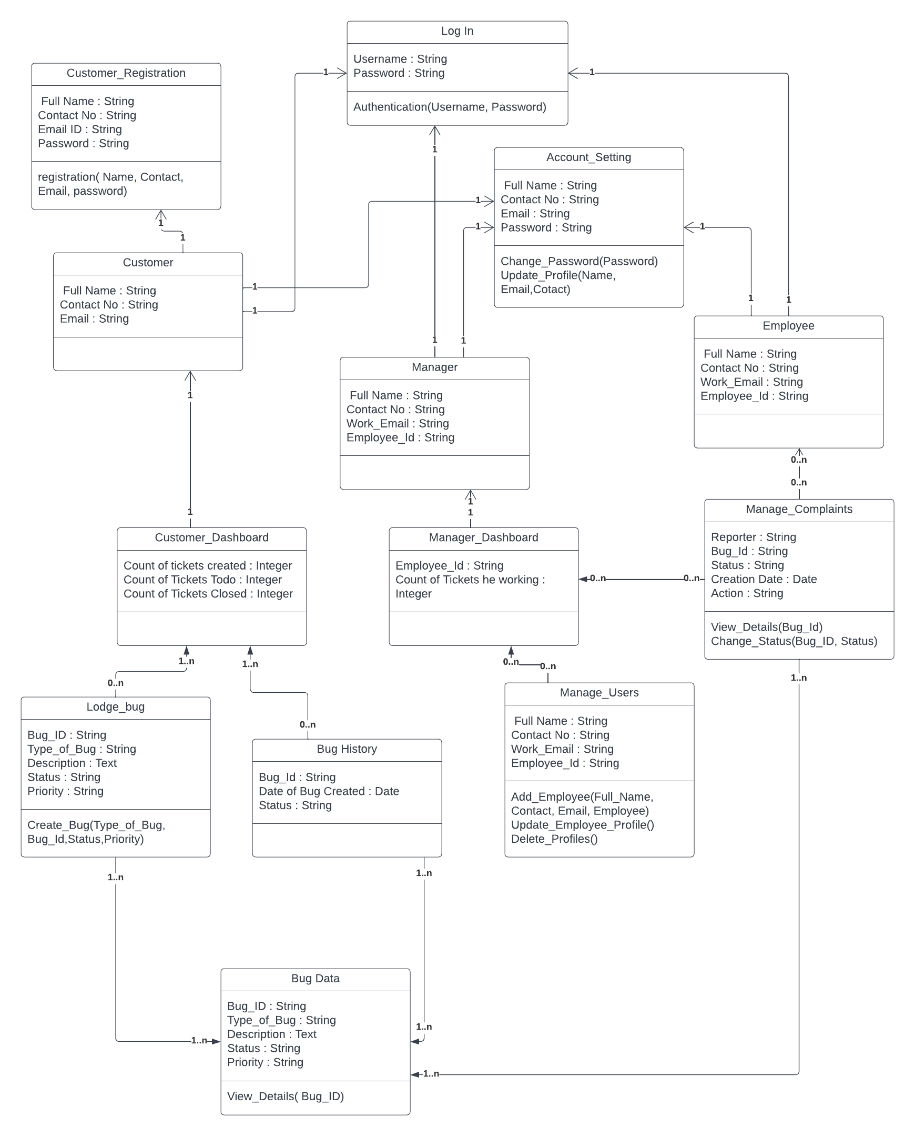

Figure 1: Class Diagram

## Sequence diagram

Sequence diagram for “The Bug Tracking System” with respect to the Phase – 2 Requirements.

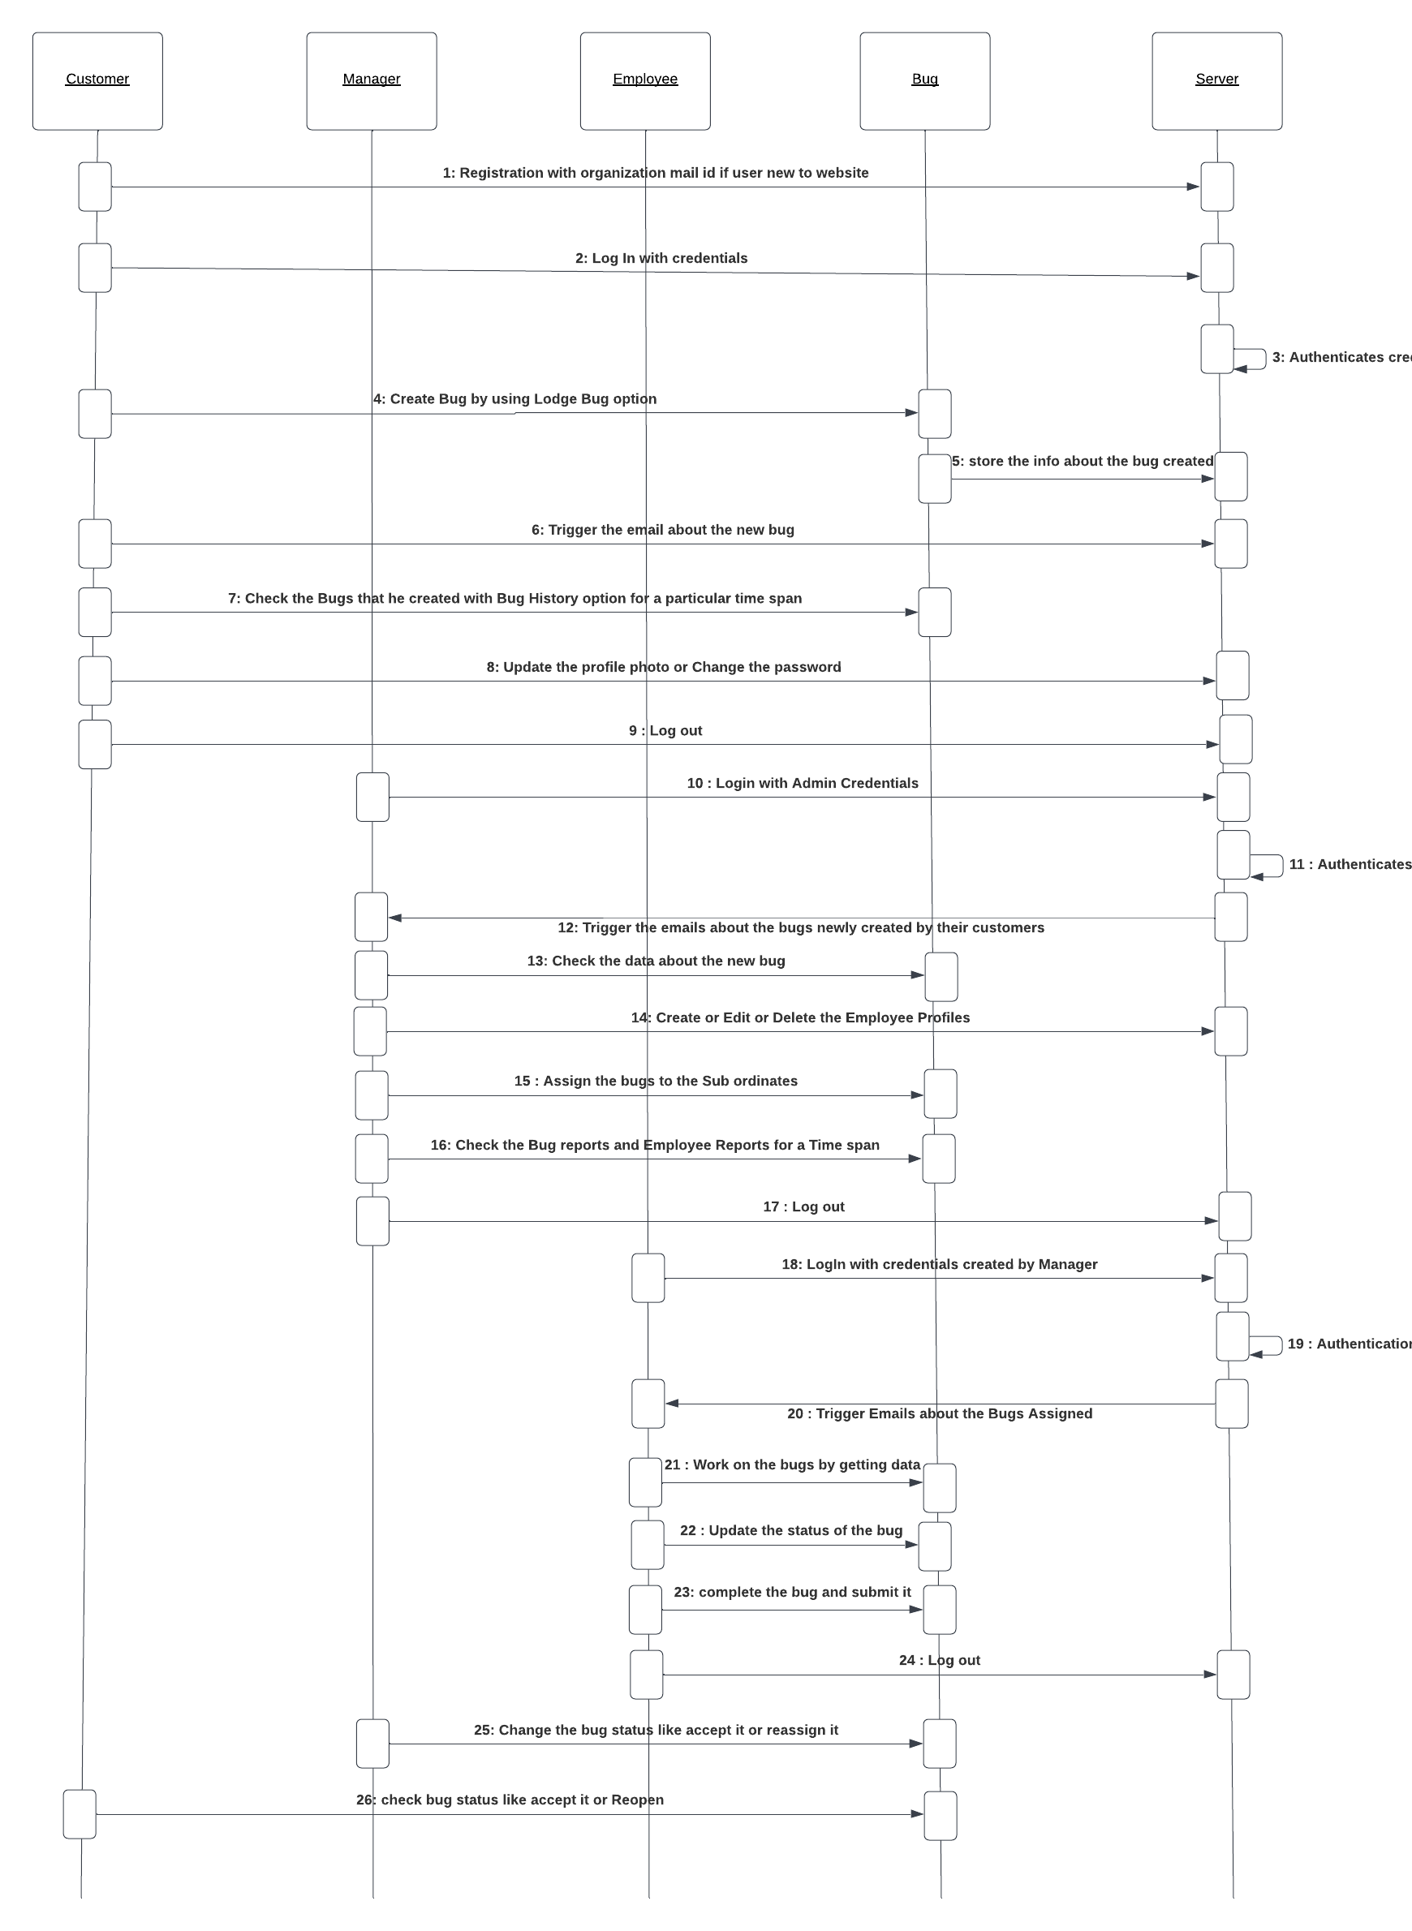

Figure 2: Sequence Diagram

## Use case diagram

Use Case diagram for “The Bug Tracking System” with respect to the Phase – 2 Requirements.

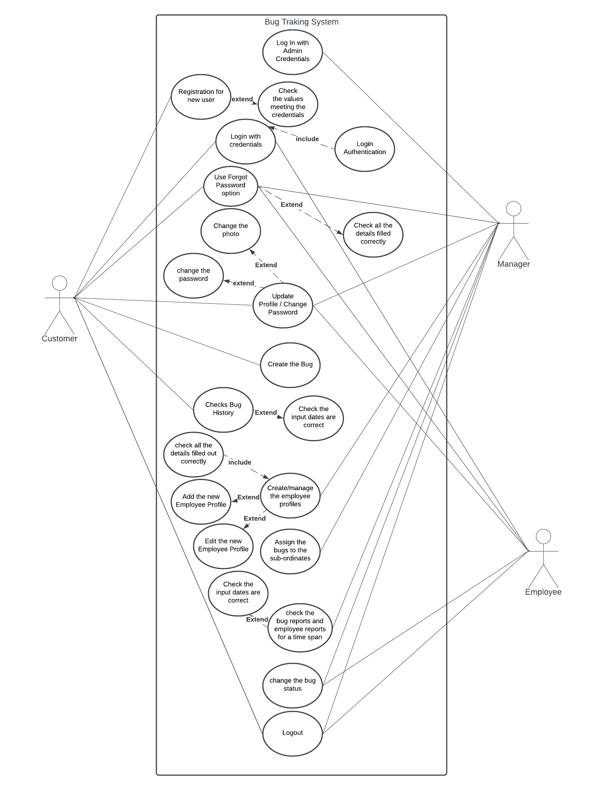

Figure 3: Use-case Diagram- normal case

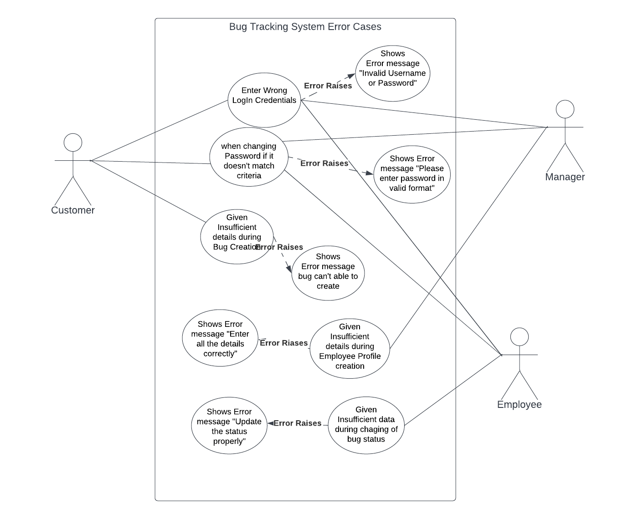

Figure 4: Use-case Diagram- error case

# Test Cases

## Customer Registration Functionality

**Input:** Entered incorrect E-mail address and tried to register.

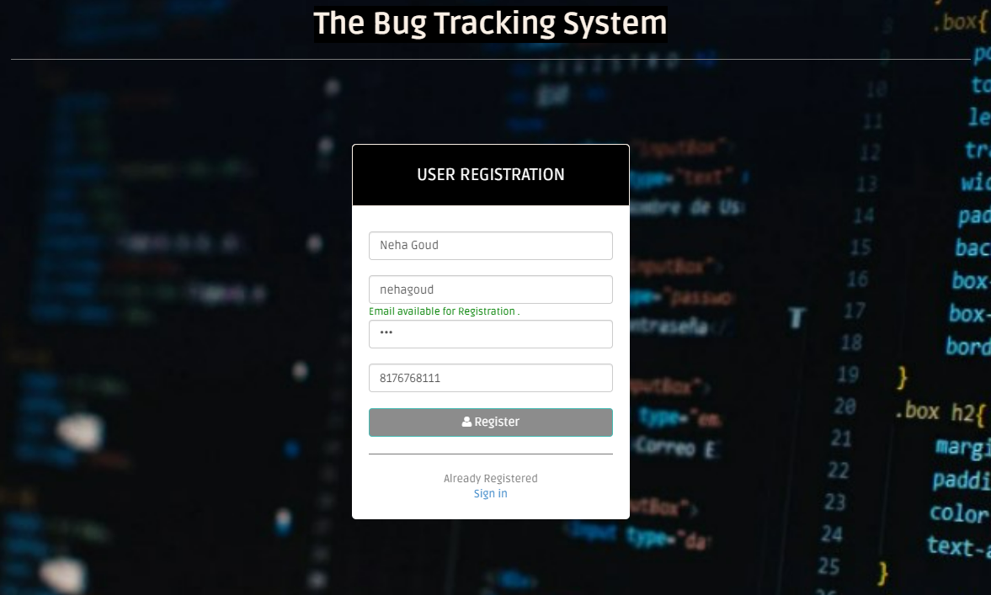

Figure 5: Test Case 1 - incorrect E-mail address

**Output:** Entered incorrect E-mail address, “error message is displayed.”

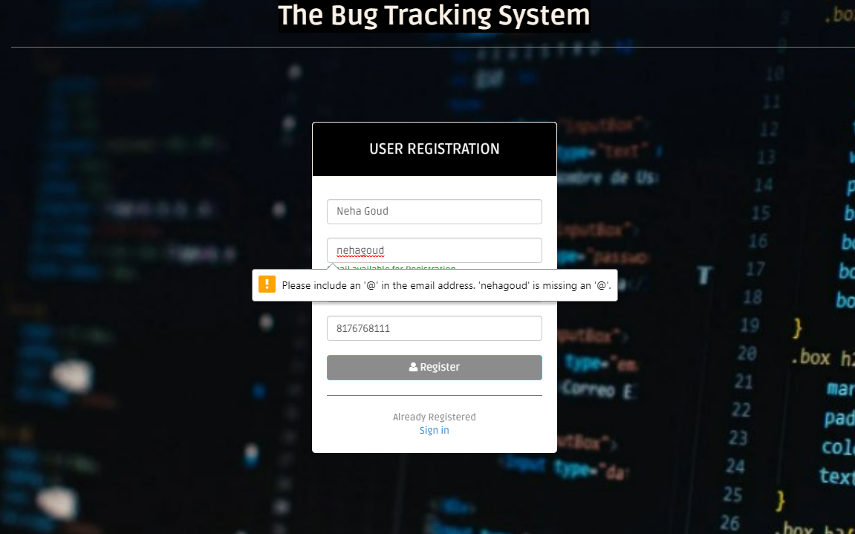

Figure 6: Test Case 1 Incorrect Email ID error

**Functionality:** Once all correct details are captured. Registration should be successful.

* Captured all the required details correctly and clicked on Register.

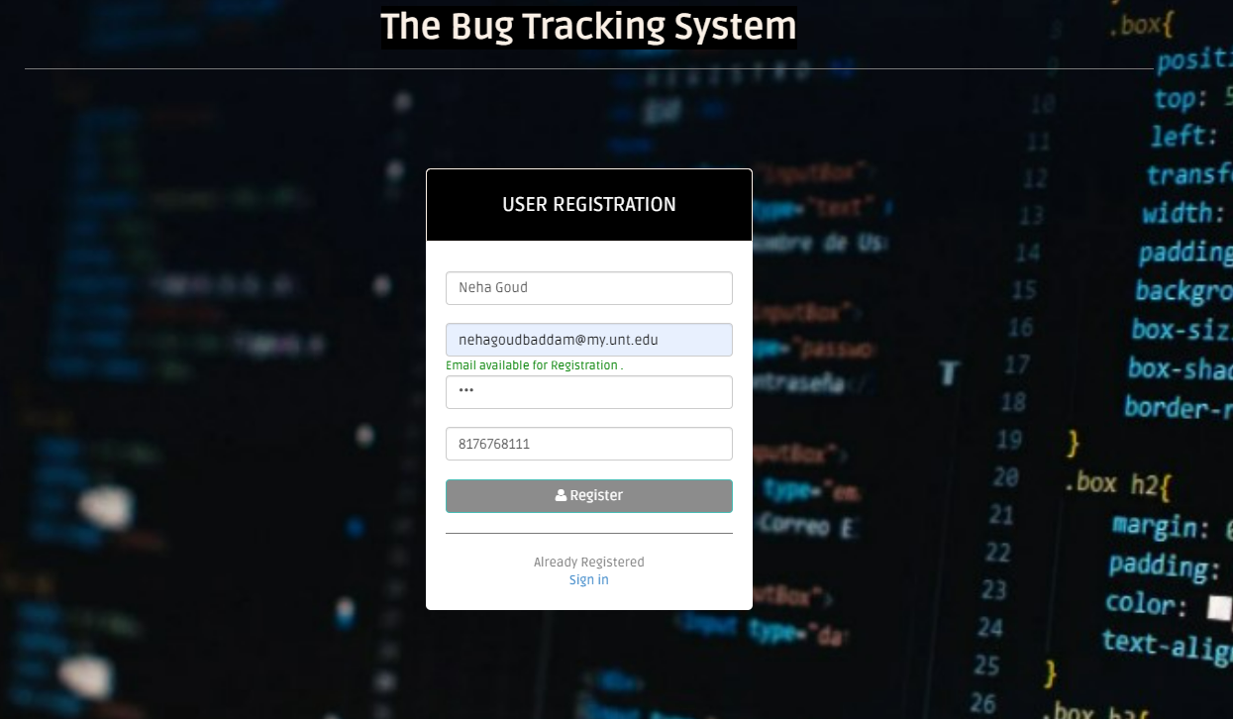

Figure 7: Test Case 1 Valid User Registration details

* User account has Registered successfully.

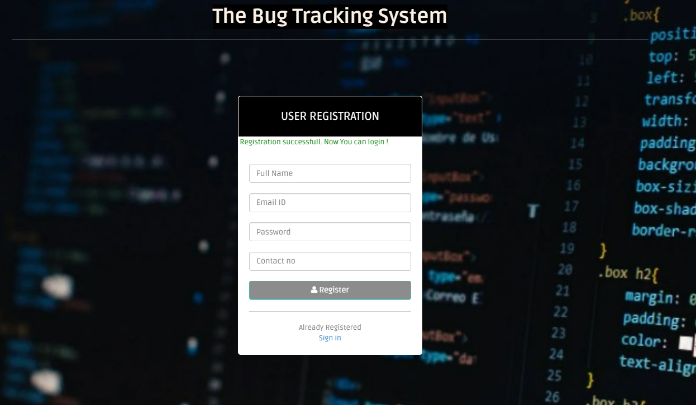

Figure 8: Test Case 1 Successful Customer Registration

## Customer Login Functionality

**Input:** Entered incorrect E-mail/Username and password.

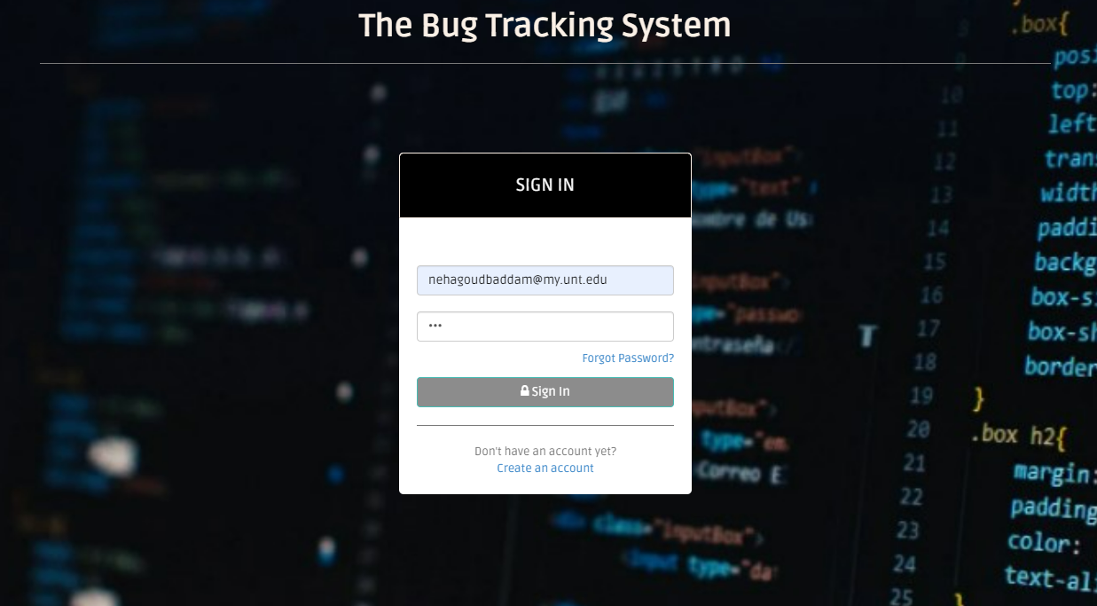

Figure 9: Test Case 2 Incorrect Login details

**Output:** Incorrect username and password error message has popped up.

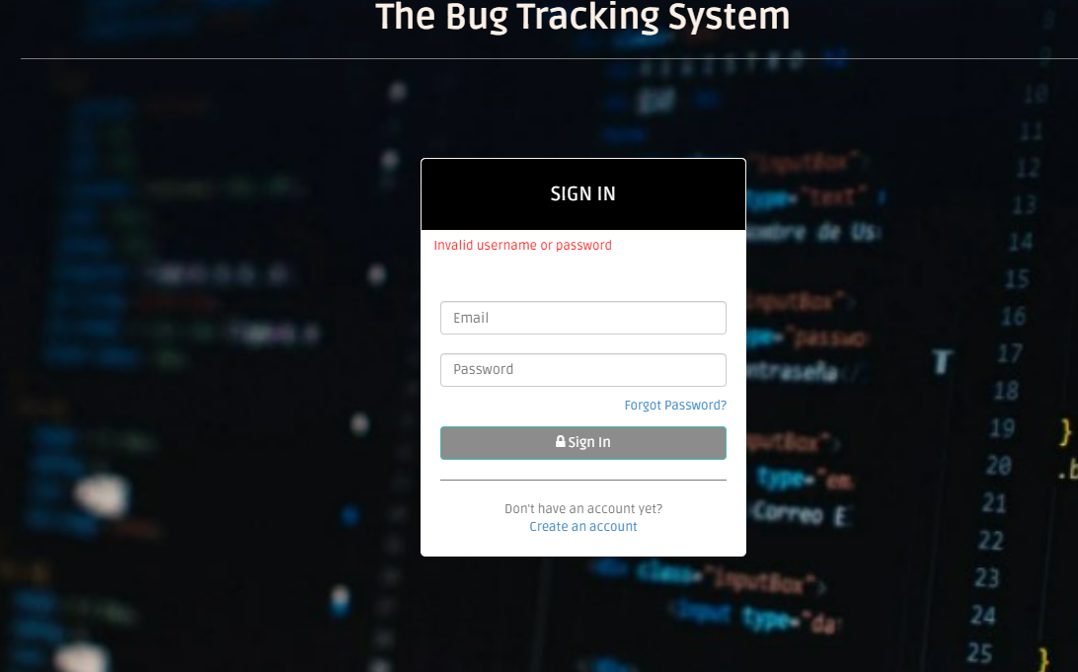

Figure 10: Test Case 2 Invalid username or password

**Functionality:** E-mail Id and Password to be validate. Login should be successful.

* Captured correct E-mail and password. Credentials are validated.



Figure 11: Test Case 2 Valid Customer Credentials

* Account has Logged in successfully.

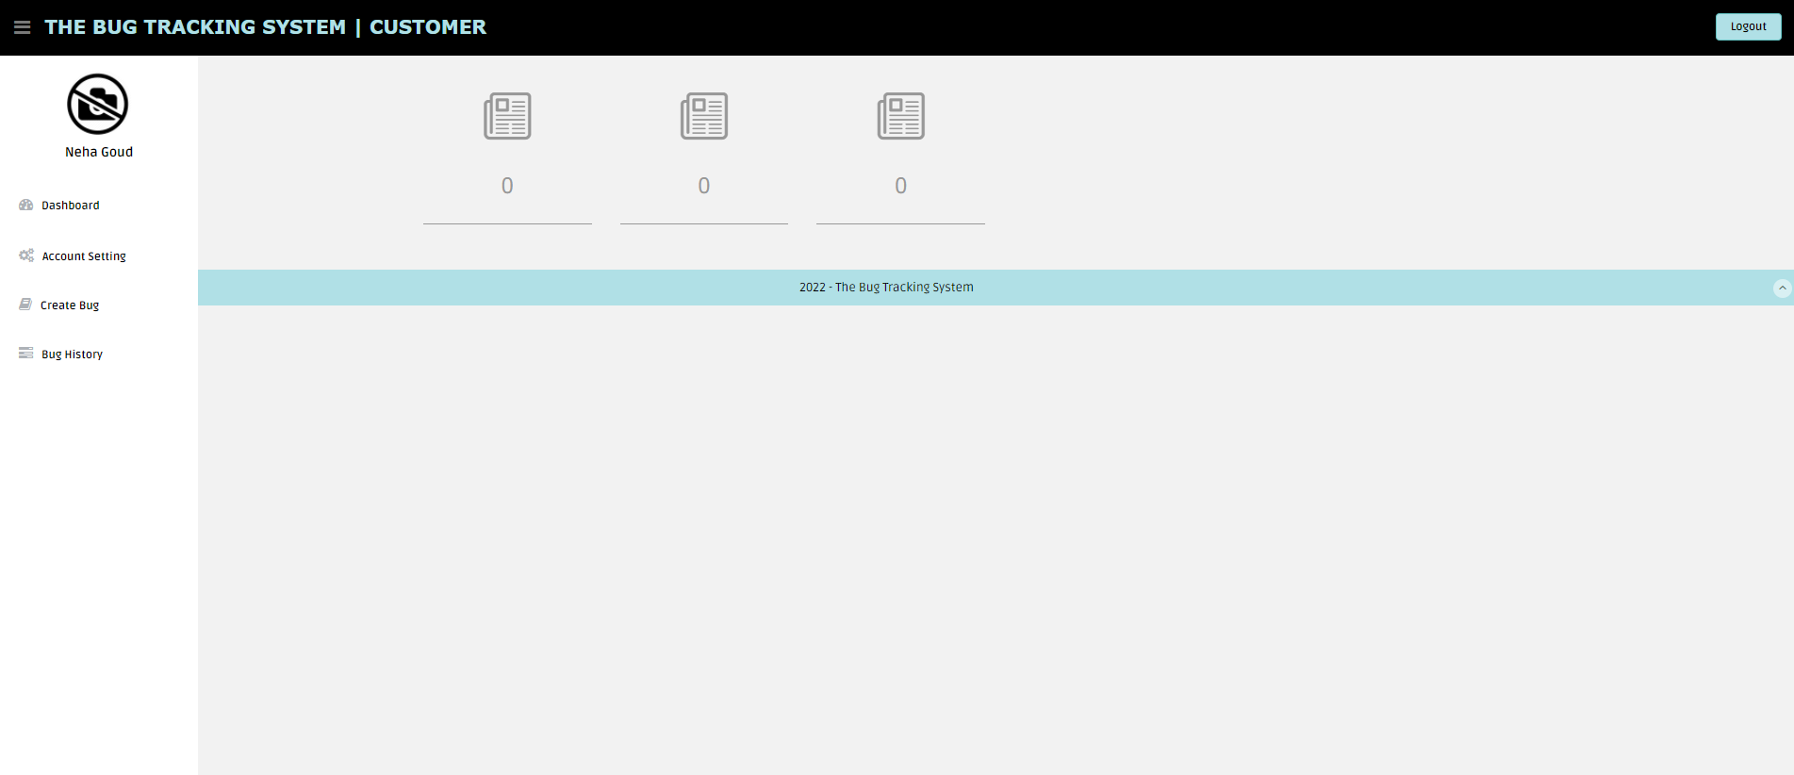

Figure 12: Test Case 2 Successful Login

## Employee/Manager Login Functionality

Evaluated by giving the unregistered email address to check whether our website check whether **Input:** Entered Login details which are not registered.

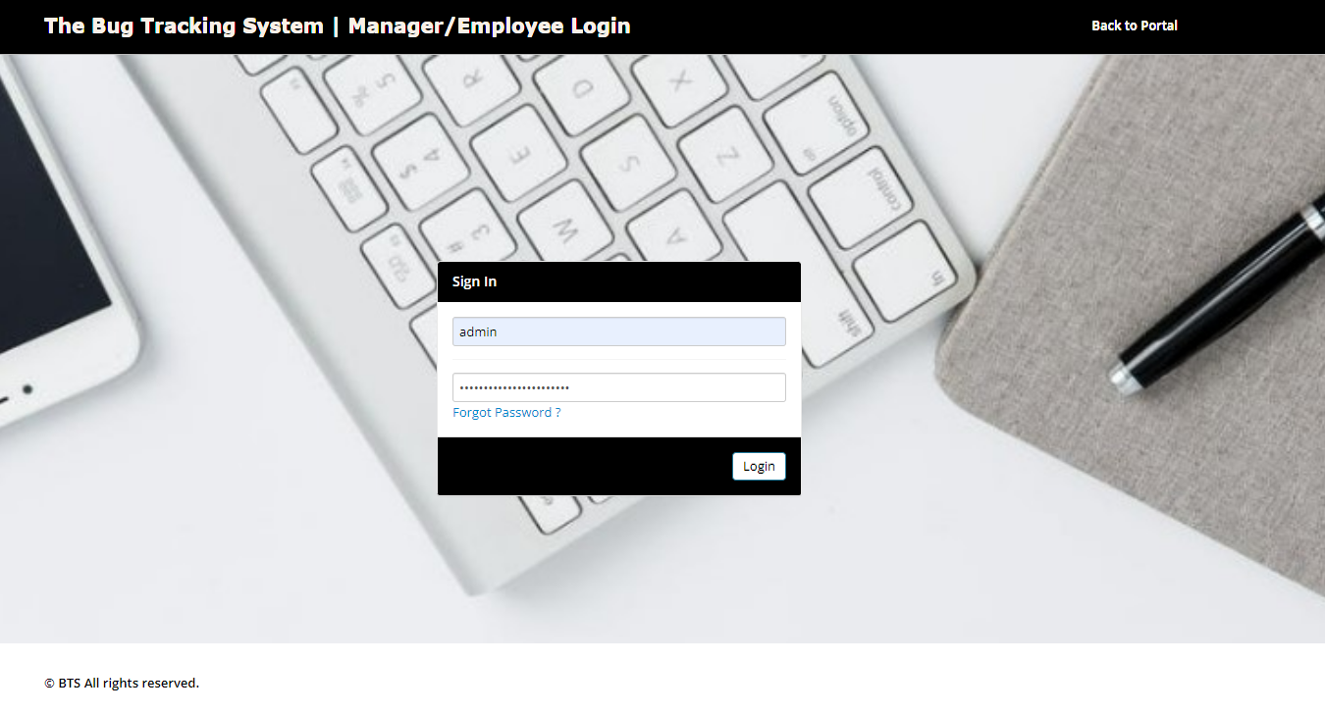

Figure 13: Test Case 3 Incorrect User Credentials

**Output:** Validate the Username and password. Throw error if the credentials are not registered.

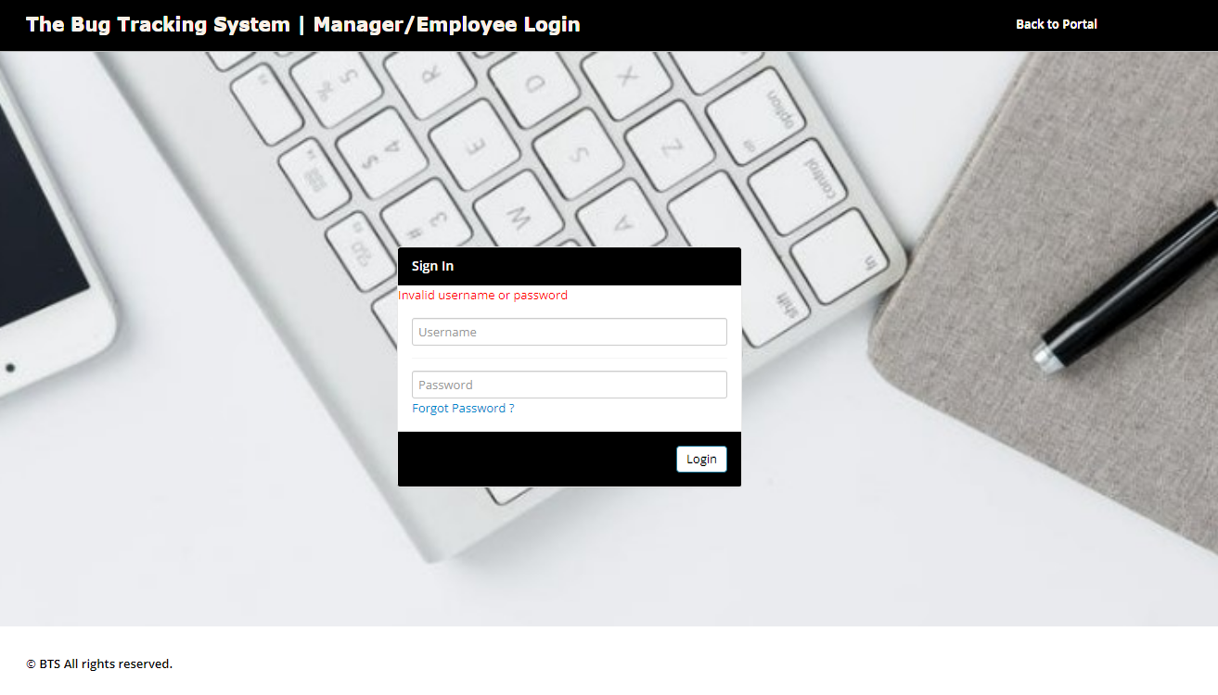

Figure 14: Test Case 3 Invalid username or password

**Functionality:** Enter correct login details which are registered in the system.

* Entered correct login details.

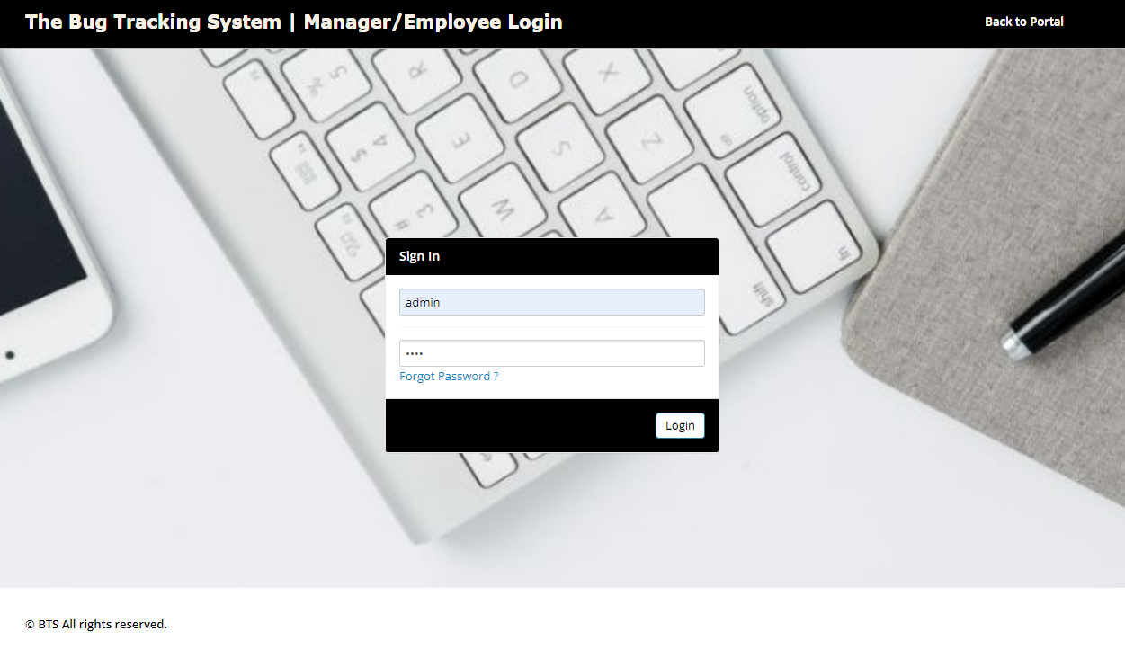

Figure 15: Test Case 3 Correct Login Details

* Account has Logged In.

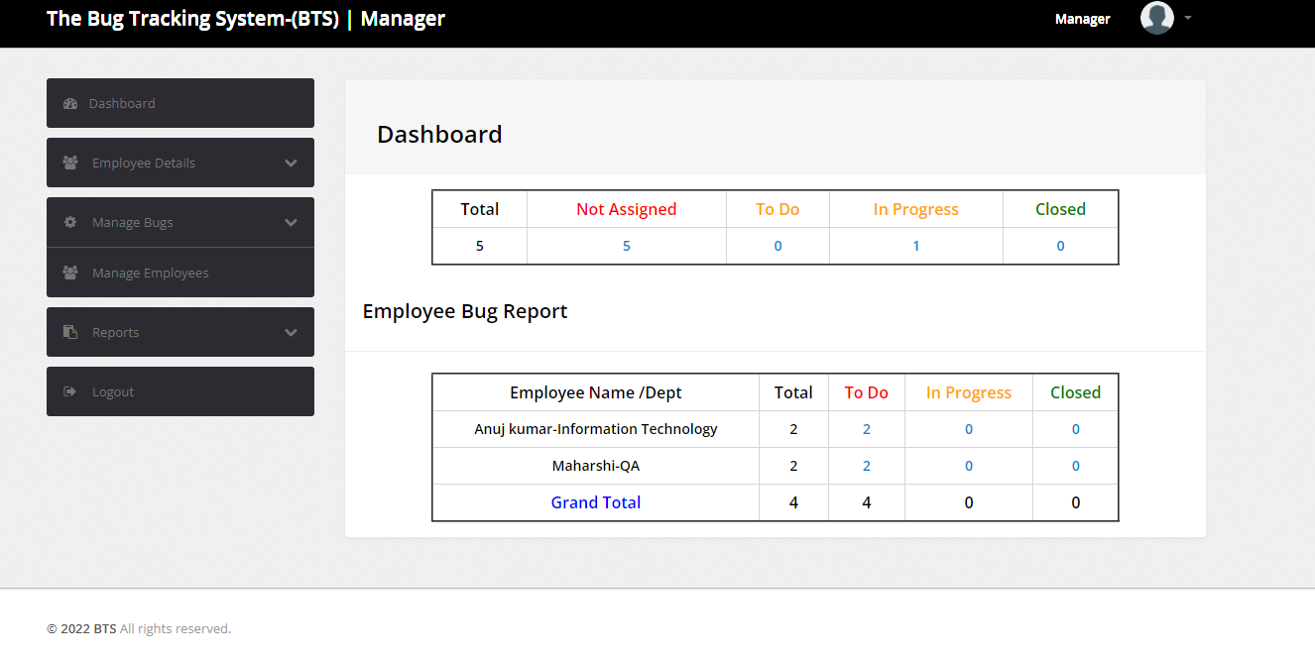

Figure 16: Test Case 3 Successful Login

## Employee Change password

**Input:** enter new password and confirm password incorrectly.

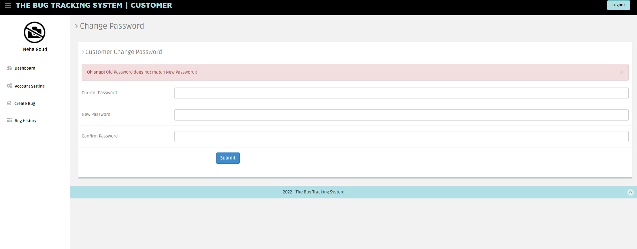

Figure 17: Test Case 4 Change password with incorrect password

**Output:** If password is mis-matched, then pop will be displayed.

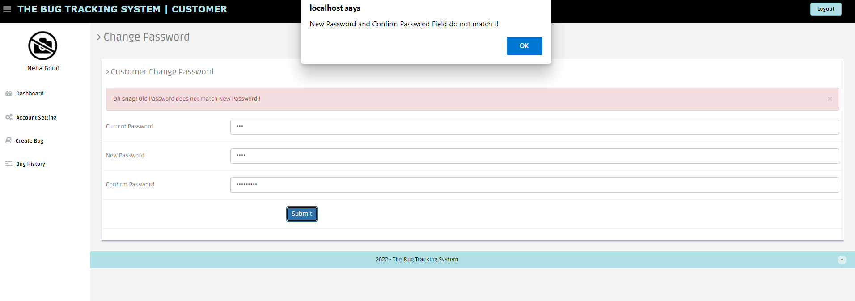

Figure 18: Text Case 4 Password and Confirm Password do not match

**Functionality:** Validate correct new password and confirm password are same. Then change should be saved.

Now Enter Valid Details, password will be saved.

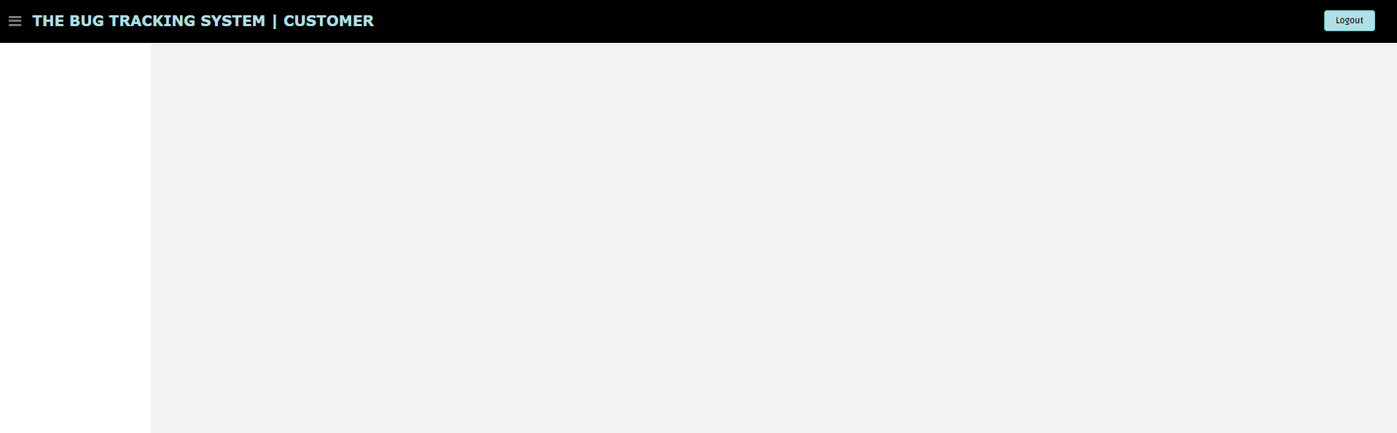

Figure 19 Test case 4: Successfully changed password

## Customer Profile Info

**Input:** we entered all the fields for the below test case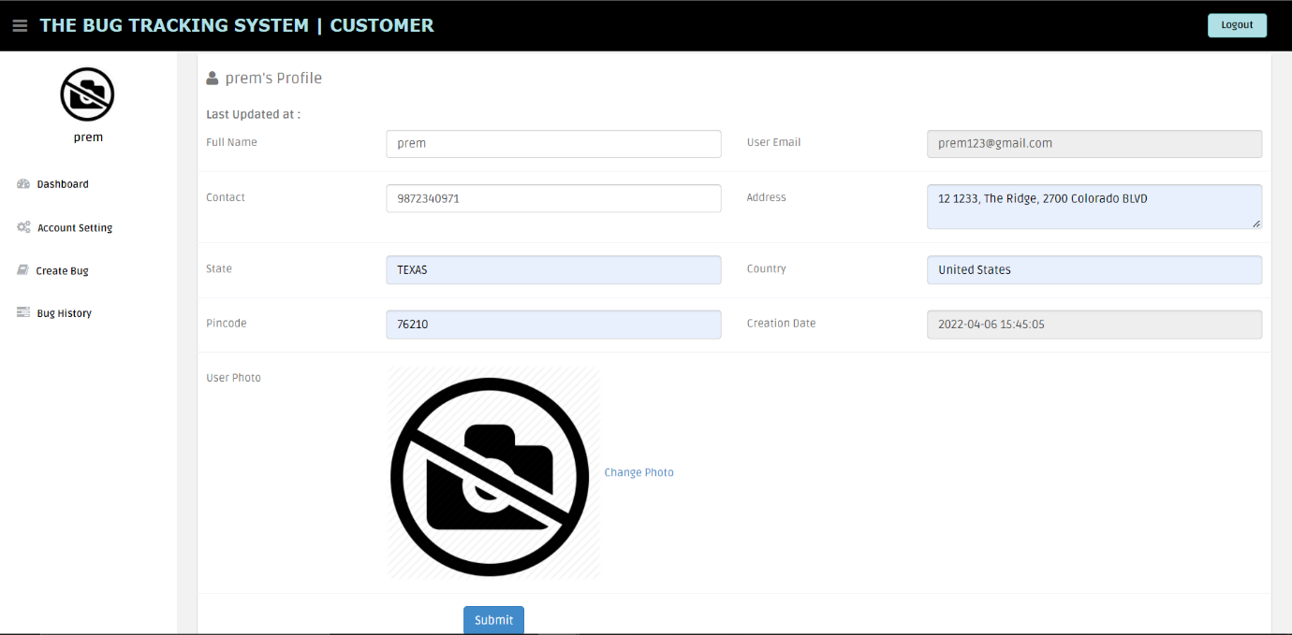

Figure 20: Customer Profile Info Page

**Output:** all the fields have been updated in this test cases

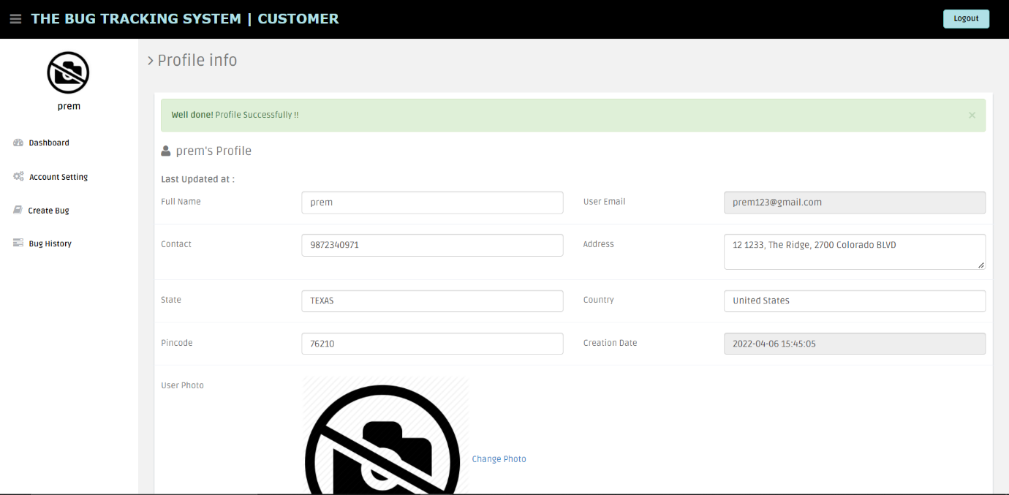

Figure 21Customer profile info updated successfully

**Functionality:** as we entered the field are correct and valid so that profile as been updated.

## Customer Profile photo updating

**Input:** we should upload the profile pic in the customer profile.

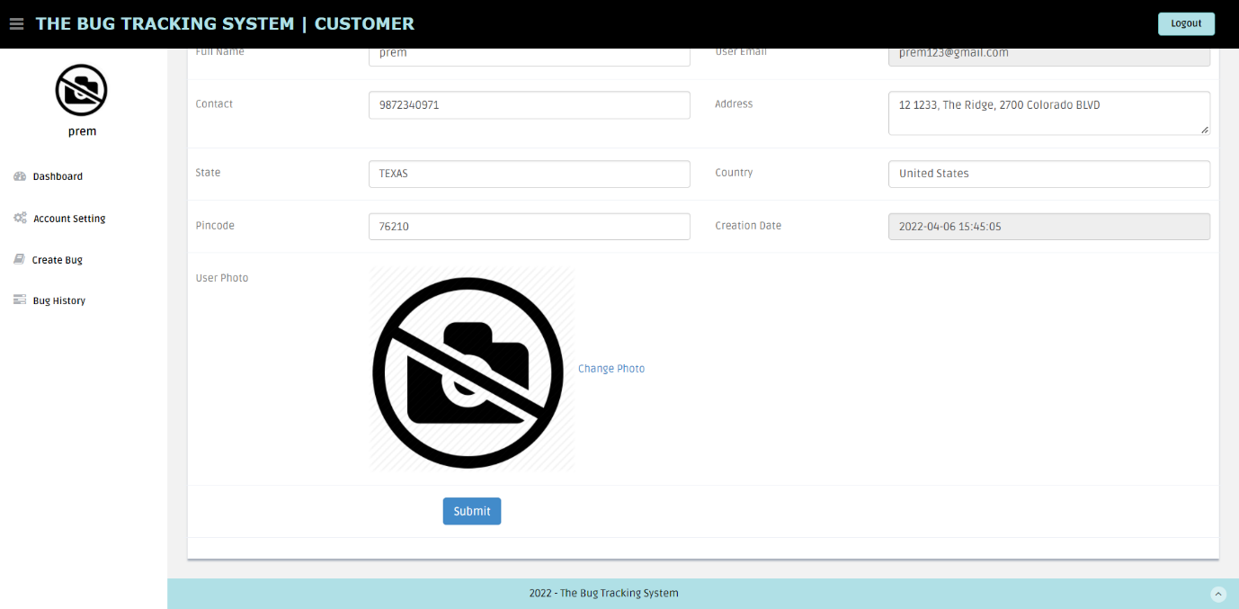

Figure 22: Customer profile photo updating page

**Output:** successfully we updated the profile pic.

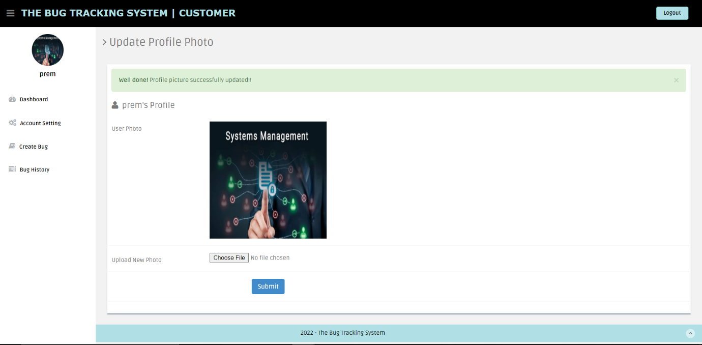

Figure 23: Customer profile picture successfully updated

**Functionality:** By this we can change or update the profile pic for the customer.

## Customer Change Password

**Input:** enter the new password and see if it is correct or not.

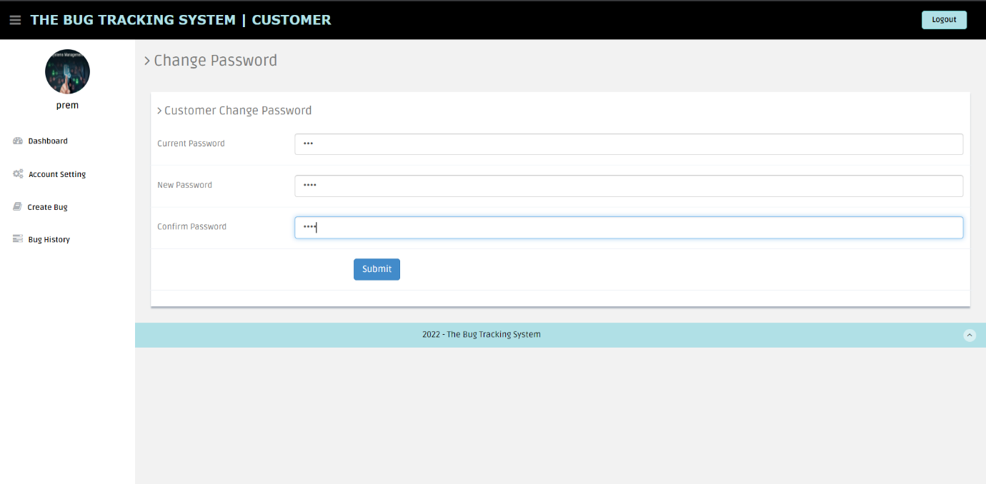

Figure 24: Customer change password Page

**Output:** so, the old password and the new password does not match.

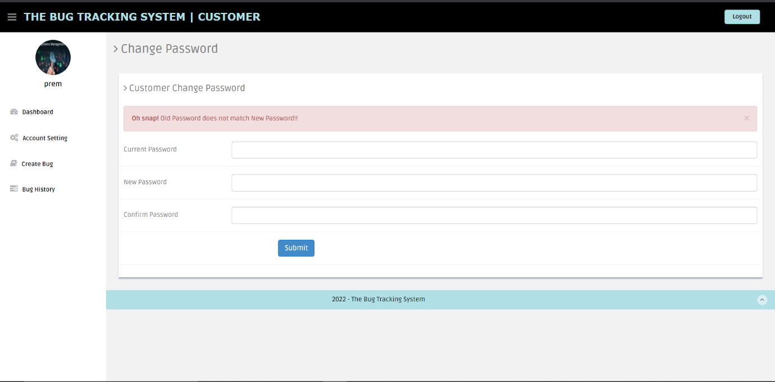

Figure 25: Incorrect password entered

**Functionality:** correct the new password and confirm password are same.

## Customer Create Bug

**Input:** we created the bug in the customer module, and we entered the fields with all the files.

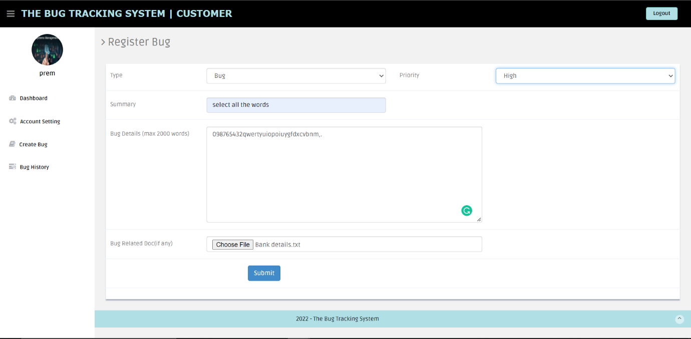

Figure 26: Customer Bug creation page

**Output:** as we updated the field in the customer profile as seen below

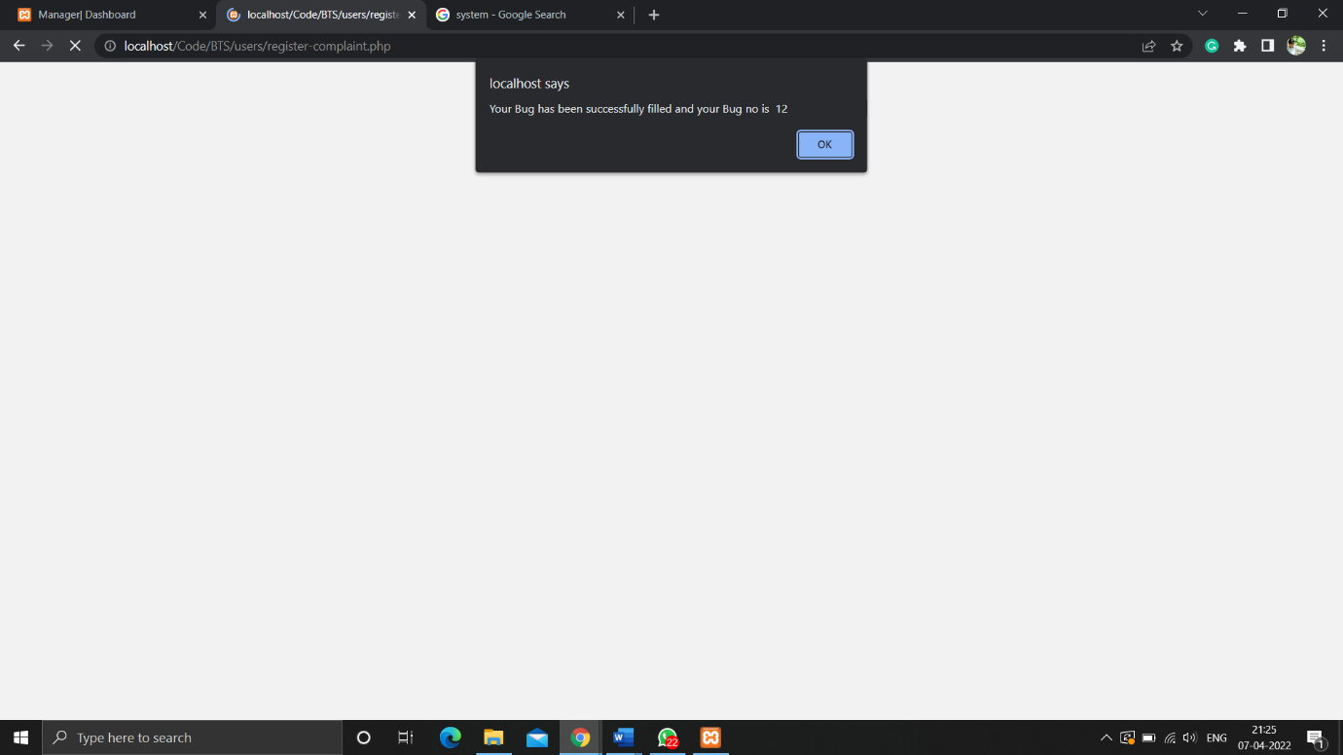

Figure 27: Bug created successfully

**Functionality:** by creating the bug we assess the bugs from the customer module.

## Customer Bug History

**Input:** in the bug history we need to see all the details the file

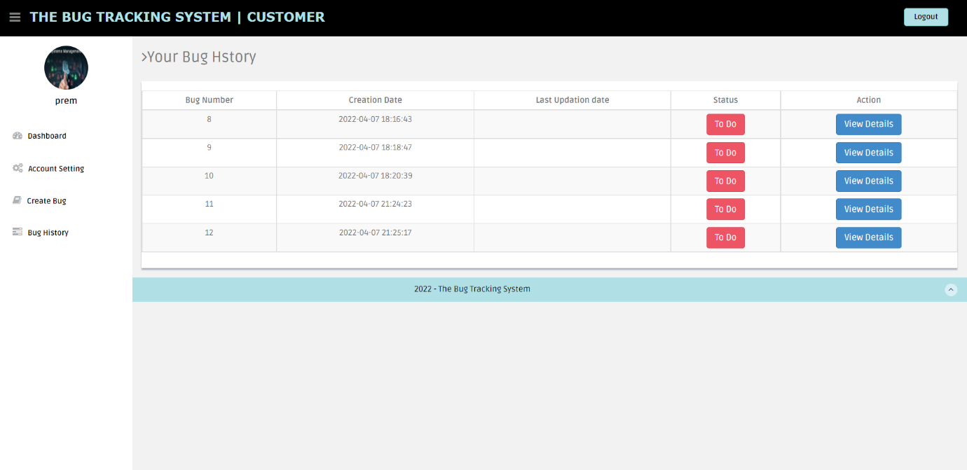

Figure 28: Customer Bug history page

**Output:** in this we can view all the details of the bug details which we need to assess

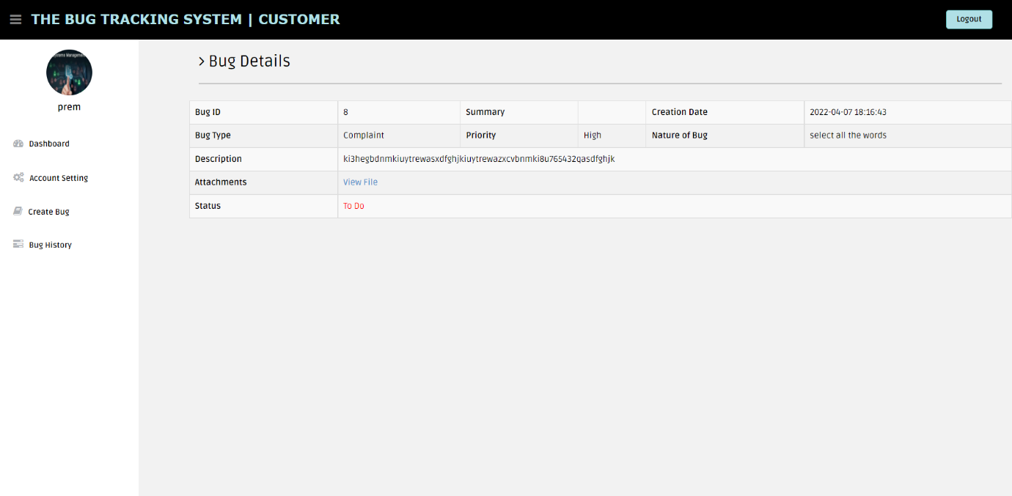

Figure 29: Customer Bug details page

**Functionality:** by this we can validate the each and every detail of the bugs.

## Manager Add Employee

**Input:** we added the employee to the manager module.

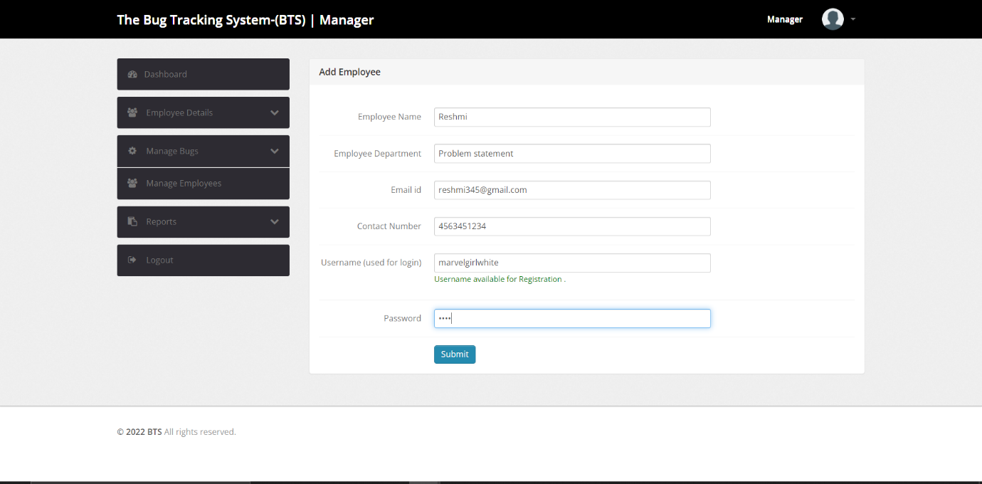

Figure 30: Manager - Add employee page

**Output:** Employee has been successfully added in the field of employee details

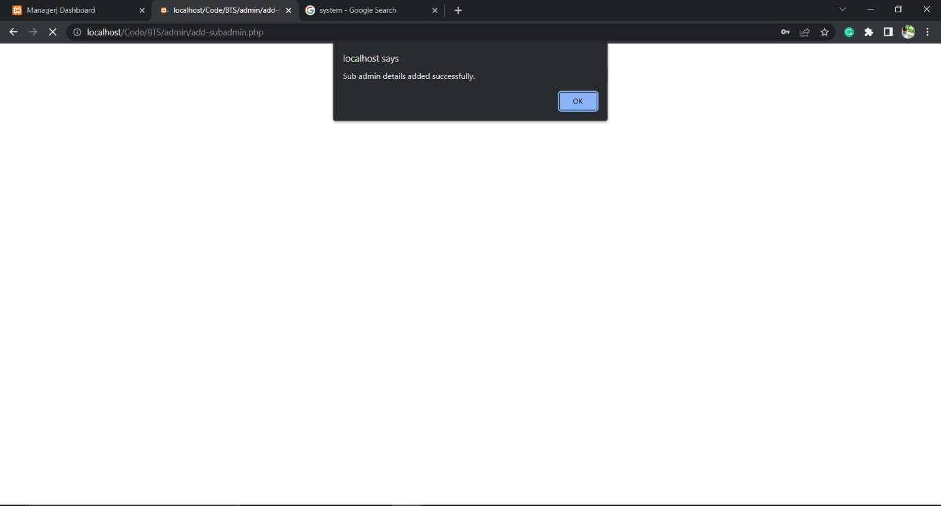

Figure 31: Successfully added employee

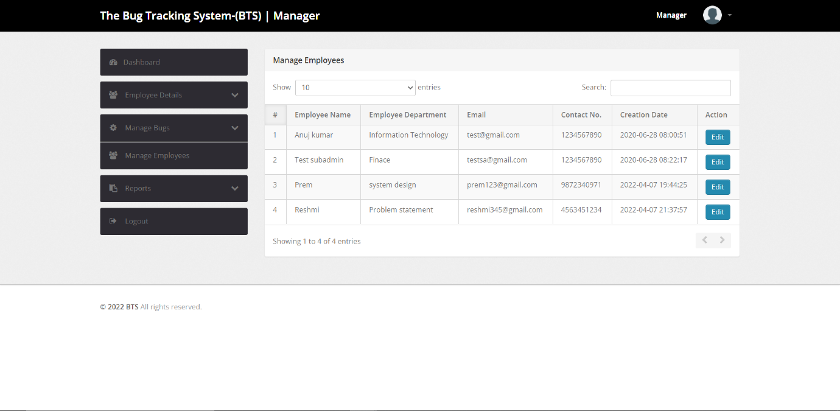

Figure 32: Manager View - manage employee page

**Functionality:** we can add more than one employee to the employee details

## Manager - Manager Employee

**Input:** we need to edit the action field of the employee details



Figure 33:Manager View - Manage employees details updating

**Output:** we can update employees’ details from the manager module.

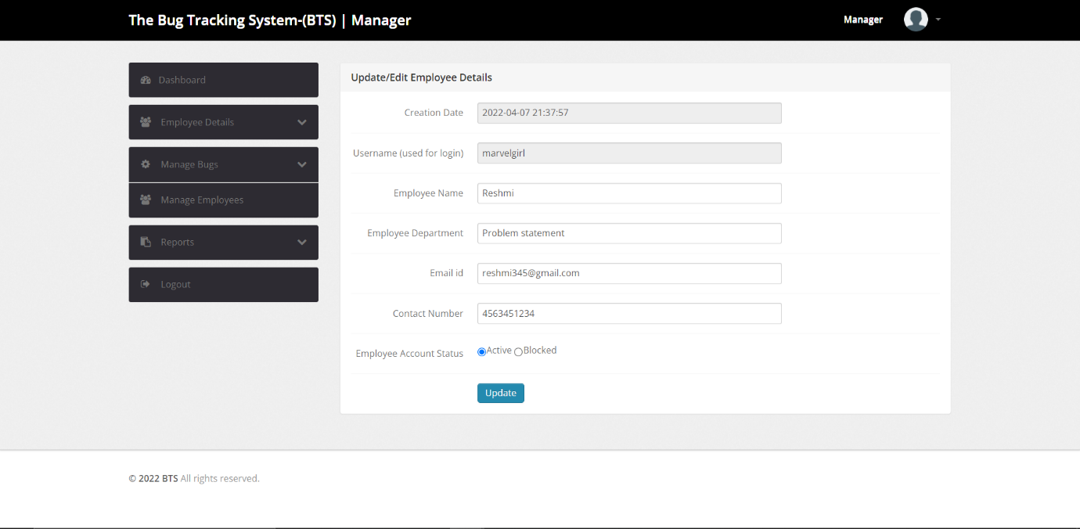

Figure 34: Manager view - Update/Edit employee details

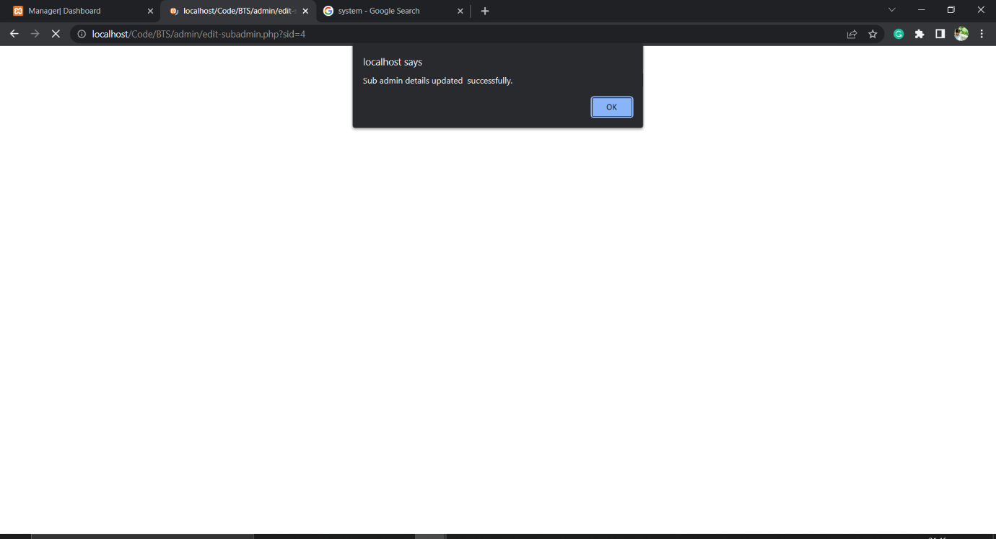

Figure 35: Manager view- employee details successfully updated

**Functionality**: by this we can update the employee details.

## Manager – Manage Bugs

**Input:** in the manage bugs we can see To-do list and view the details by that we can assign the work.

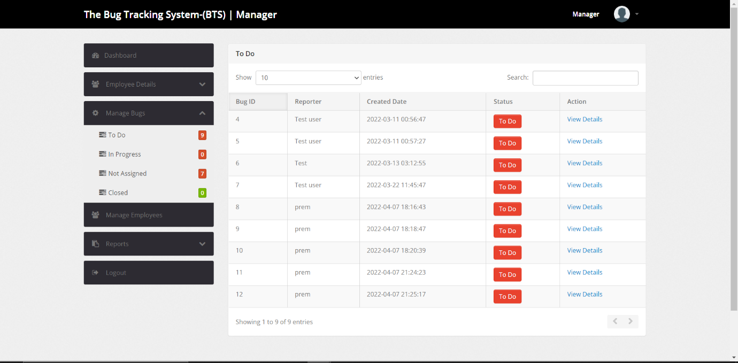

Figure 36: Manager View - Manage Bugs page

**Output:** manager module will deal with the manage bugs of each detail of the system.

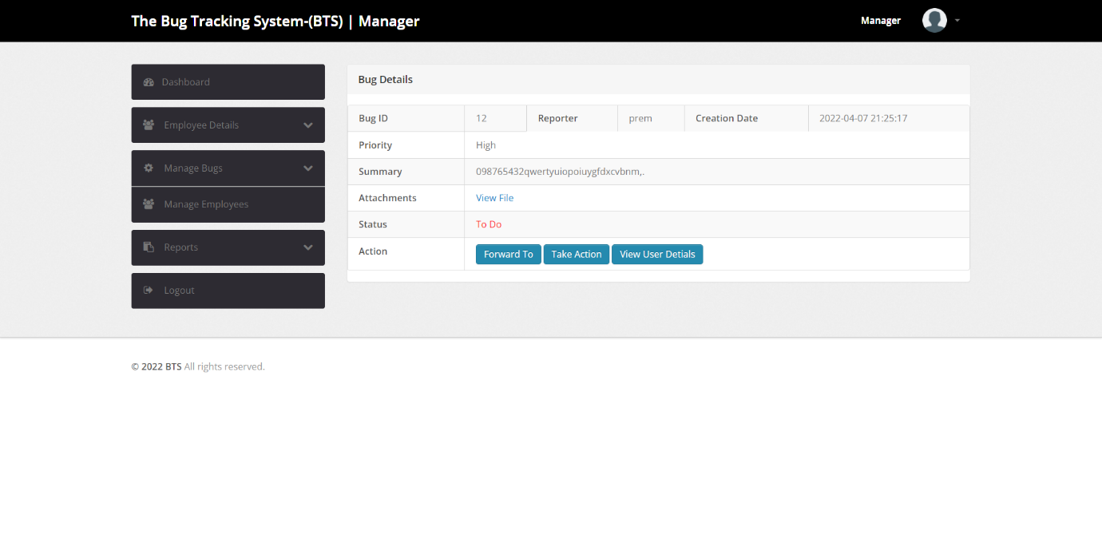

Figure 37: Manager BView - Bug details page

**Functinality**: manager can manage the bugs in the bug details.

## Manager – Bug Forwarding

**Input:** manager can forward these to any of the employee by the bug details.

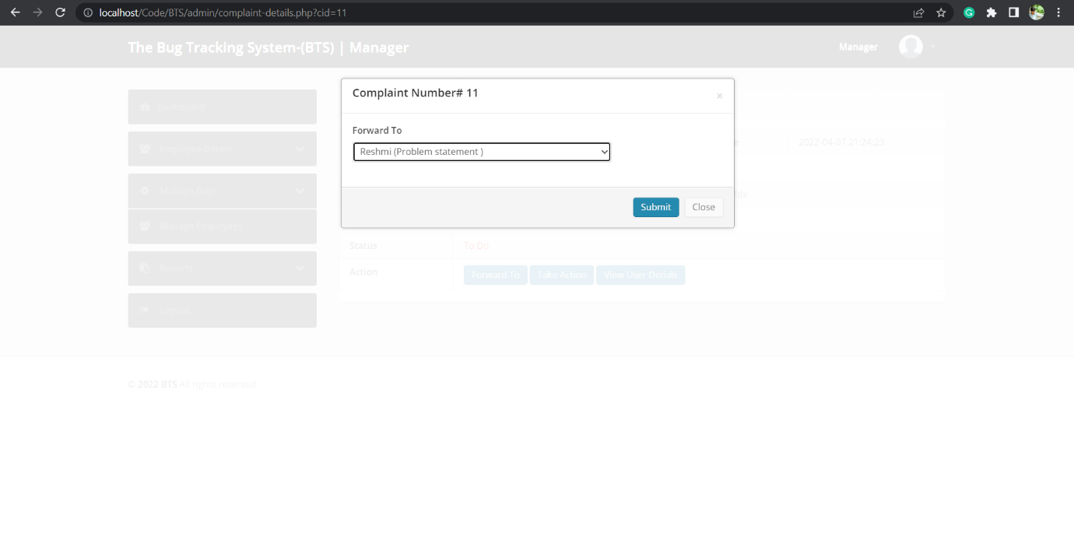

Figure 38: Manager View - Bug forwarding page

**Output:** By this manager can forward the bug to the employee.

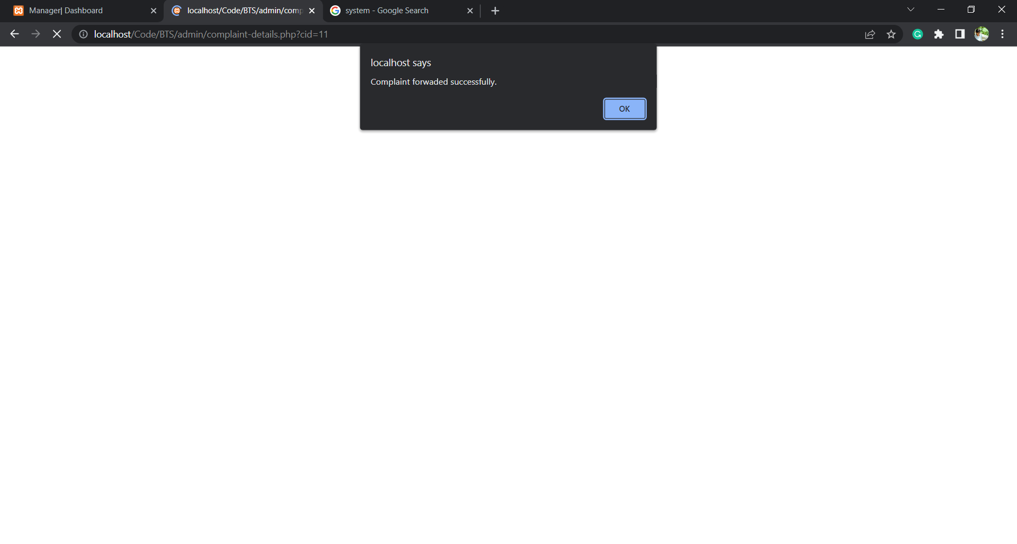

Figure 39: Manage View - successfully forwarded Bug

**Functinality**: manager can forward the bugs to employees.

## Manager – Manage Users

**Input:** In the bug tracking system we can see the details of the system of the employee.

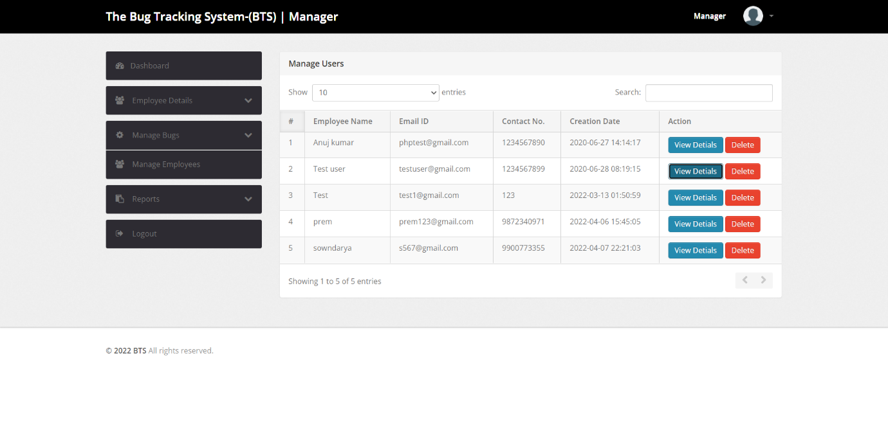

Figure 40: Manager View - Manage Users Page

**Output**: we can view the details of the employee id and even the contact no and the creation details and even the action of the bug tracking

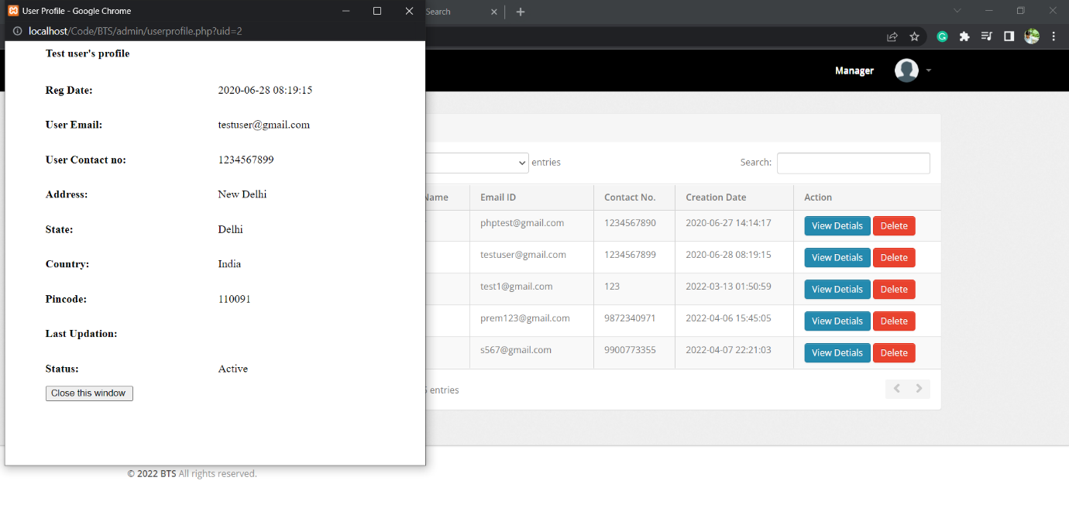

Figure 41:Manager View - View employee details

**Functionality:** when the details employee can see the profile

# User Manual for Phase - 2

The Bug Tracking System is a Web Application, used by Customers and Organization to track the bugs in their software.

Follow the Program Compilation and Run Instructions to setup the program on your system and type the URL, main page will be displayed. <http://localhost/BTS>

## Main Page:

Use the Buttons on the top of the “Main Page” to navigate. Customer will use buttons “Customer Login” and “Customer Registration.” Manager/Employee will use “Manager/Employee Login” button.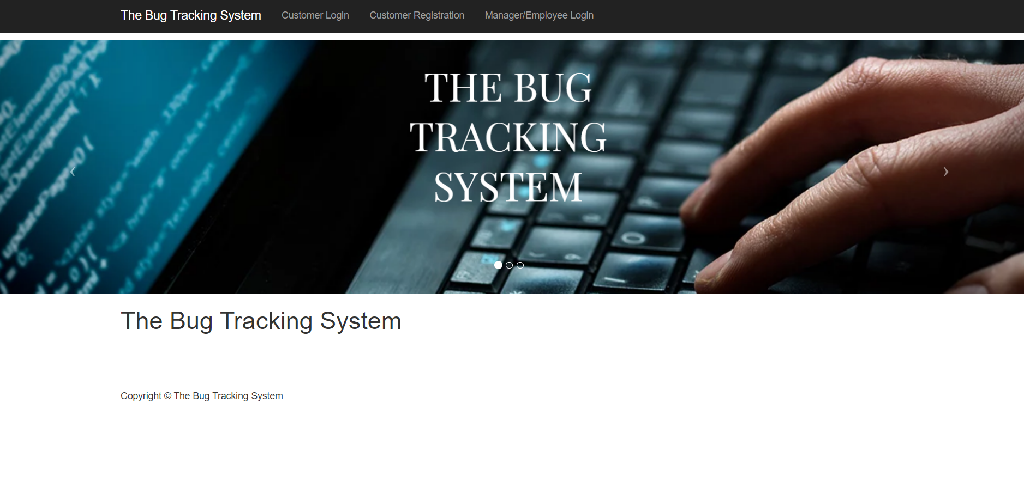

Figure 42: Main Page

### Customer Registration

* This component is specific to Customers.
* Customers can initially register with their organizations email id and password using the button “Customer Registration” on the Main Page.
* Click on the button “Customer Registration,” Registration page will be displayed, fill the details like Full Name, Email Id, Password and Contact No. (Fields validation is also done.)
* Once the account is registered, login by clicking “Sign in” button on the bottom.

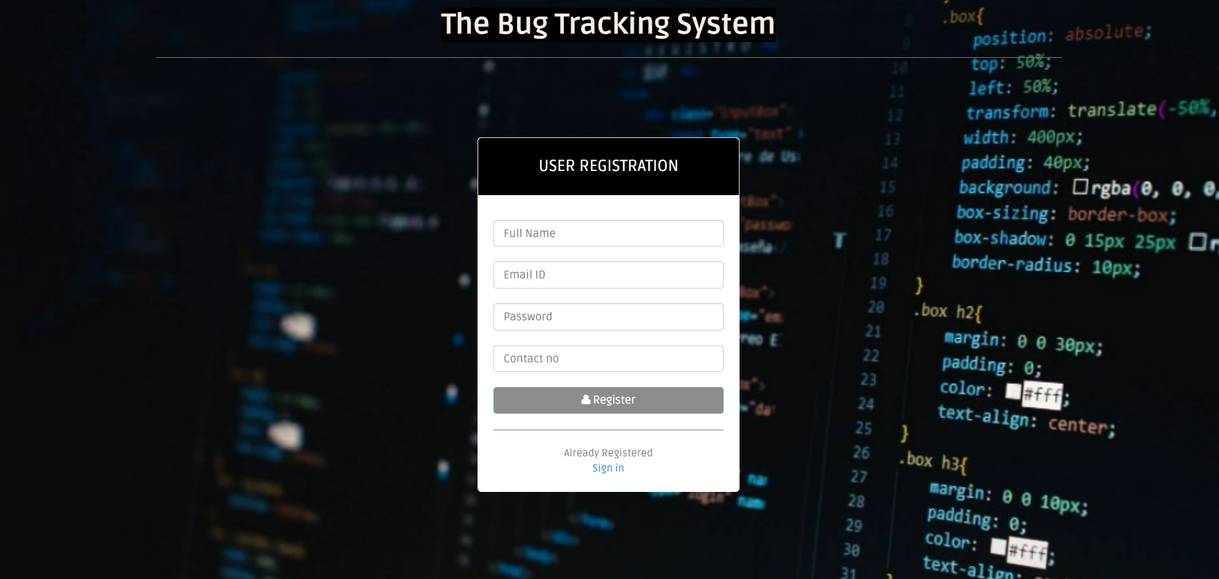

Figure 43: Customer Registration Page

### Customer Login/Sign in

* Click on button “Customer Login” and enter login credentials. (Validation of credentials is done.)

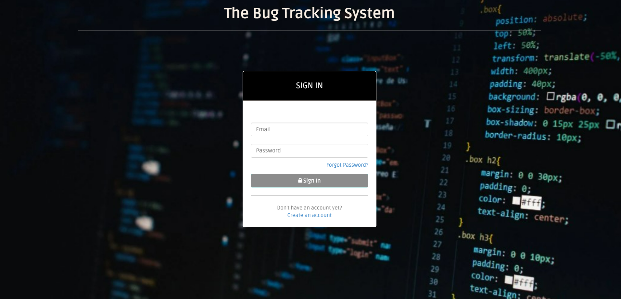

Figure 44: Customer Login Page

* Enter valid details, if not error “Invalid Username or Password” is popped.

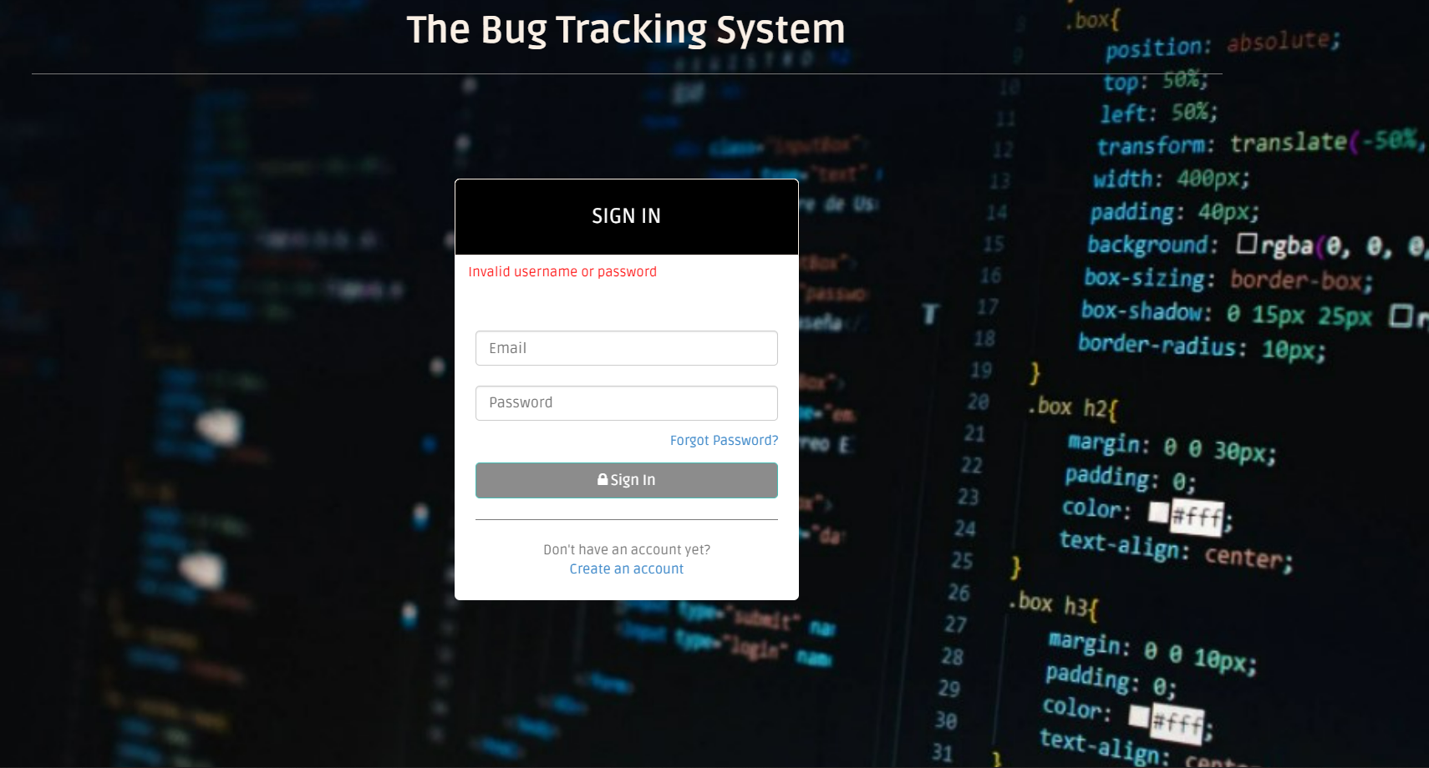

Figure 45: Invalid login details

* “Forgot Password” button is also available to change the password anytime. To change the password, enter Email Id, Contact No., New password and Confirm password fields.
* Once submitted with correct Email Id and Contact No, password will be updated successfully. Cancel option will cancel the password from updating.

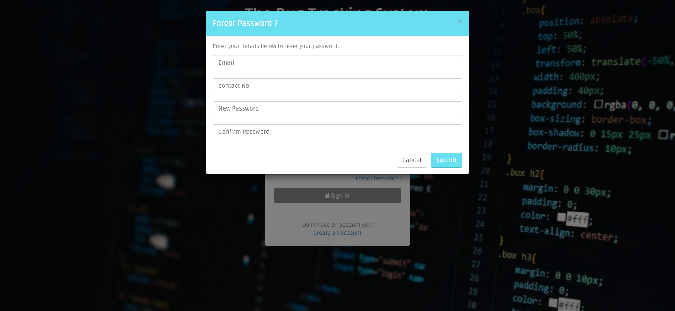

Figure 46: Forgot Password Option

### Manager/Employee Login

#### Manager Login

* Click on “Manager/Employee Login” on the “Main Page” and enter login credentials. Validation of credentials is done. If details are wrong, error “Invalid Username or Password” is popped.

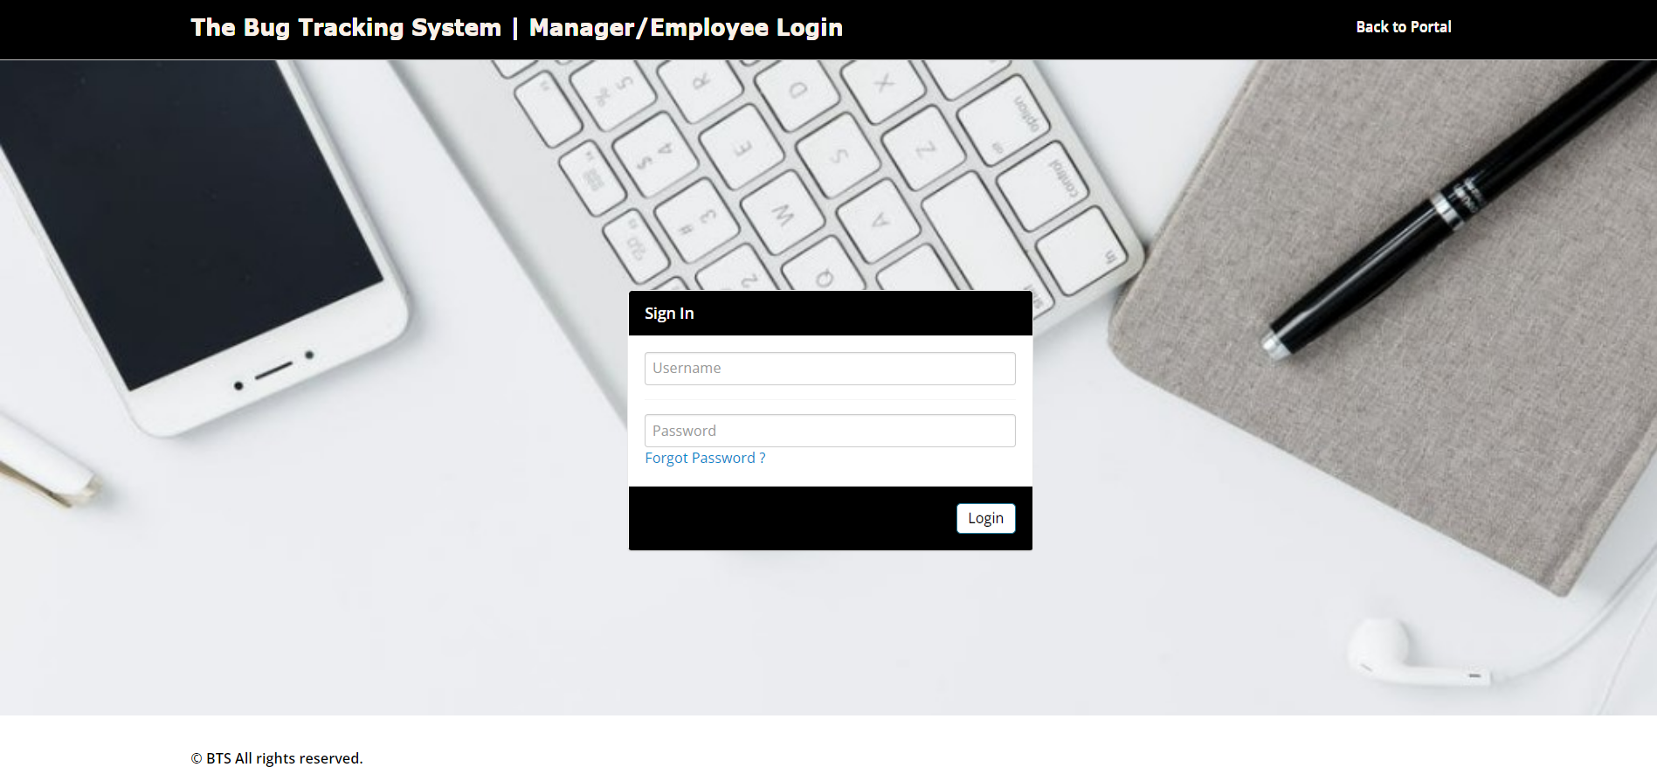

Figure 47: Manager Login Page

* “Forgot Password” button is also available to change the password anytime. It requires User Type (Either Employee or Manager), Username, Email ID/Contact No fields to be filled. Once submitted with correct details, password will be updated successfully.

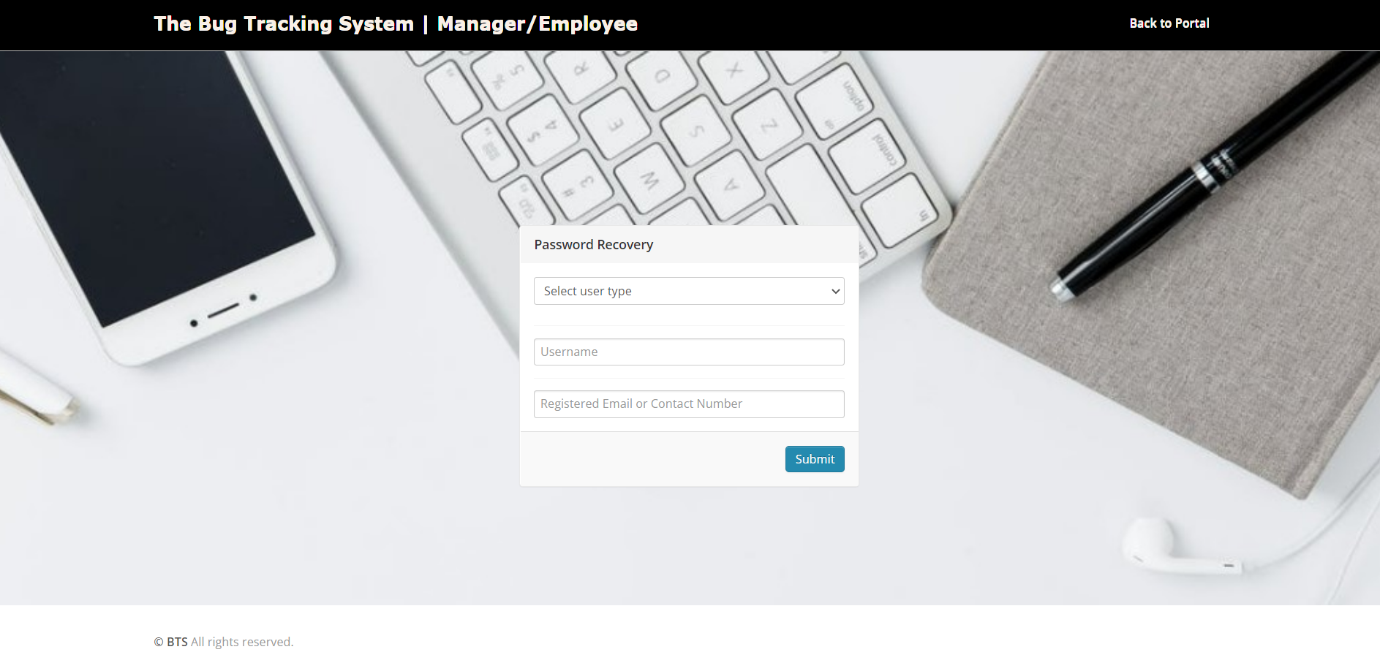

Figure 48: Manager Forgot Password Option

#### Employee Login

* Once manager creates a new employee, they share the credentials to the employee.
* Click on “Manager/Employee Login” on the “Main Page” and enters login credentials. Validation of credentials is done. If details are wrong, error “Invalid Username or Password” is popped.



Figure 49: Employee Login Page

* “Forgot Password” button is also available to change the password anytime. It requires User Type (Either Employee or Manager), Username, Email ID/Contact No fields to be filled. Once submitted with correct details, password will be updated successfully.



Figure 50: Employee forgot password option

## Customer View

Once the customer logs in, Dashboard is displayed by default. Customer View has following sections:

### Dashboard:

Dashboards display count of all the tickets created by the user that are in To Do, In Progress and Closed.

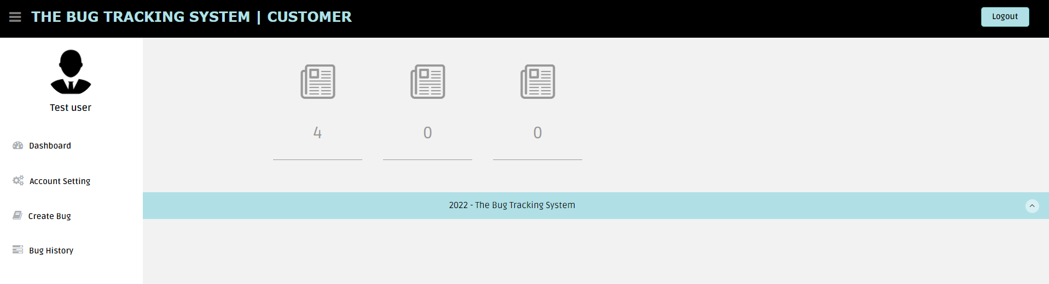

Figure 51: Customer Dashboard Display

### Account Setting:

Account settings have two buttons, profile and change password.

#### Profile:

Profile button will display customers profile information and user can also edit/update personal information.

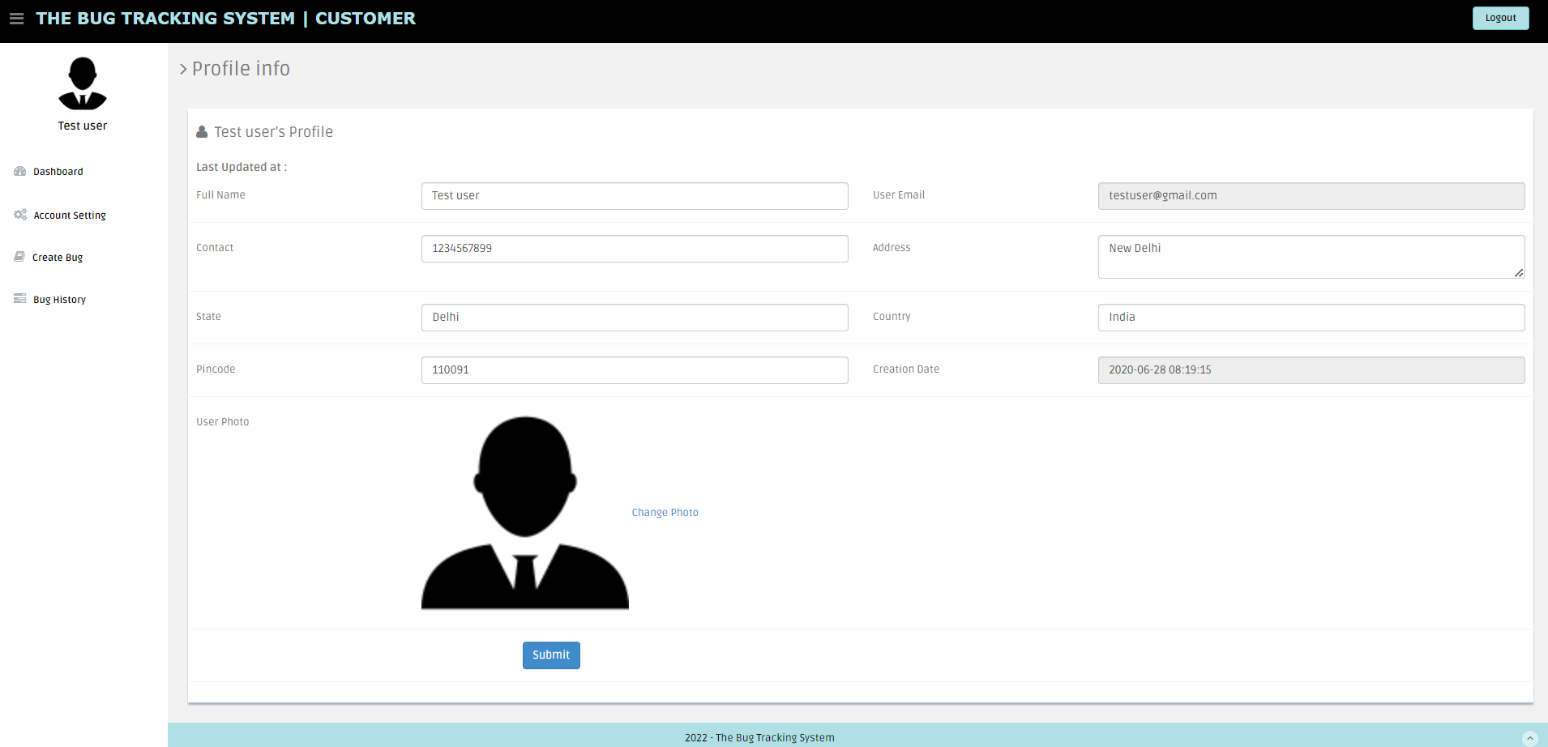

Figure 52: Customer Profile information

##### Change Photo:

“Change photo” option lets customer to update their profile picture. The customer can use “choose file” option to insert image from their system and click on “submit” option to update the picture. Once updated message “Well Done! Profile picture updated successfully” is displayed. If invalid format document is uploaded error “Invalid format. Only jpg / jpeg/ png /gif format allowed” is displayed. If picture is not successfully uploaded error “Profile picture not updated !!” is displayed.

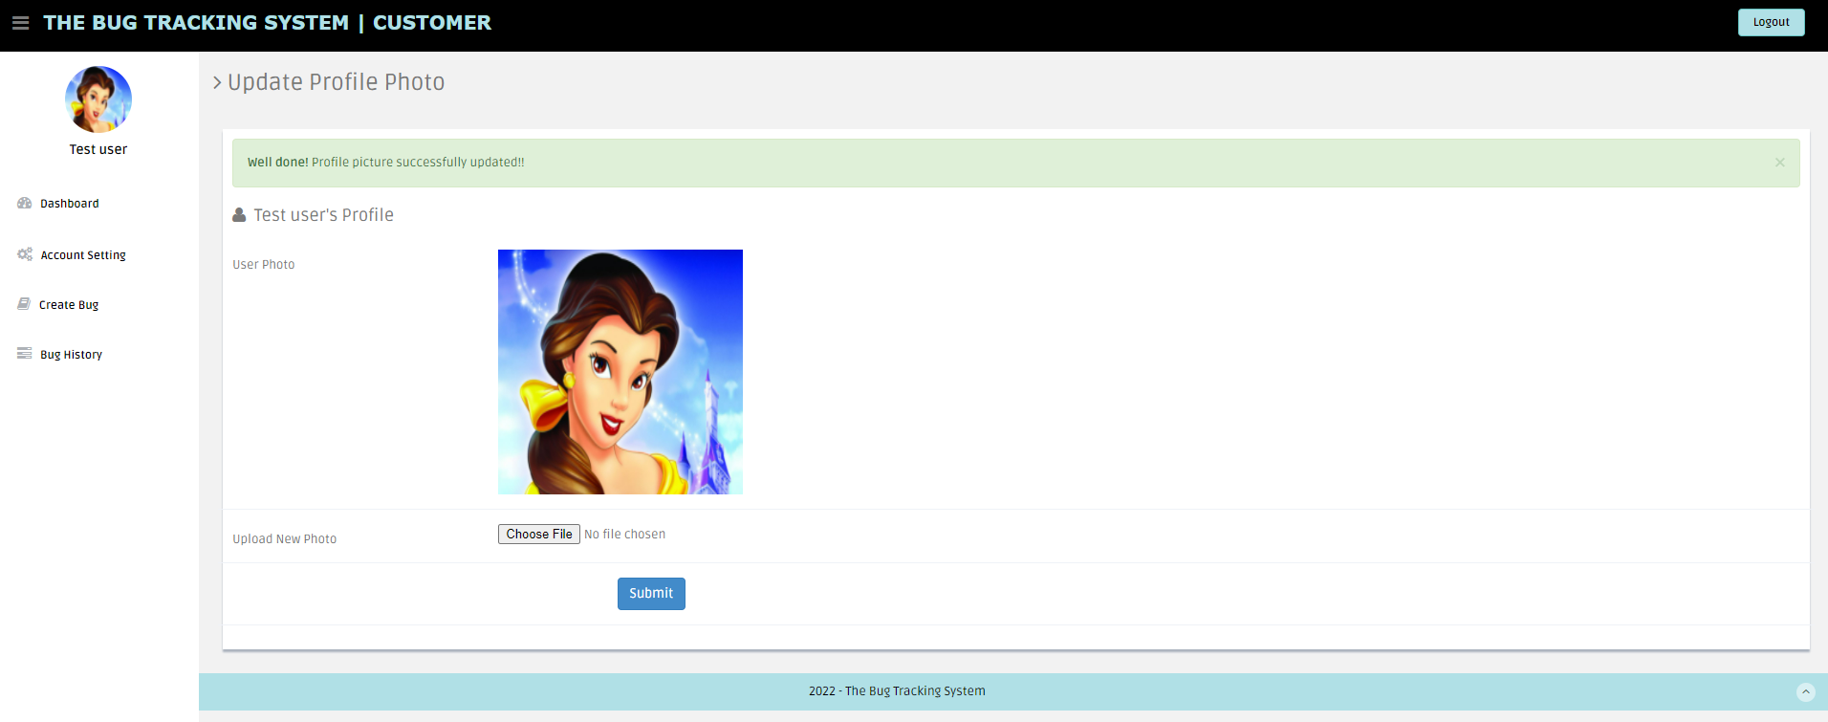

Figure 53: Customer Profile picture updating

#### Change Password:

Change password button is used for changing password. Customer can enter Current password, new password and Confirm password fields and submit for updating the password. If current password is wrong, “Oh Snap! Old password does not match” error is popped.

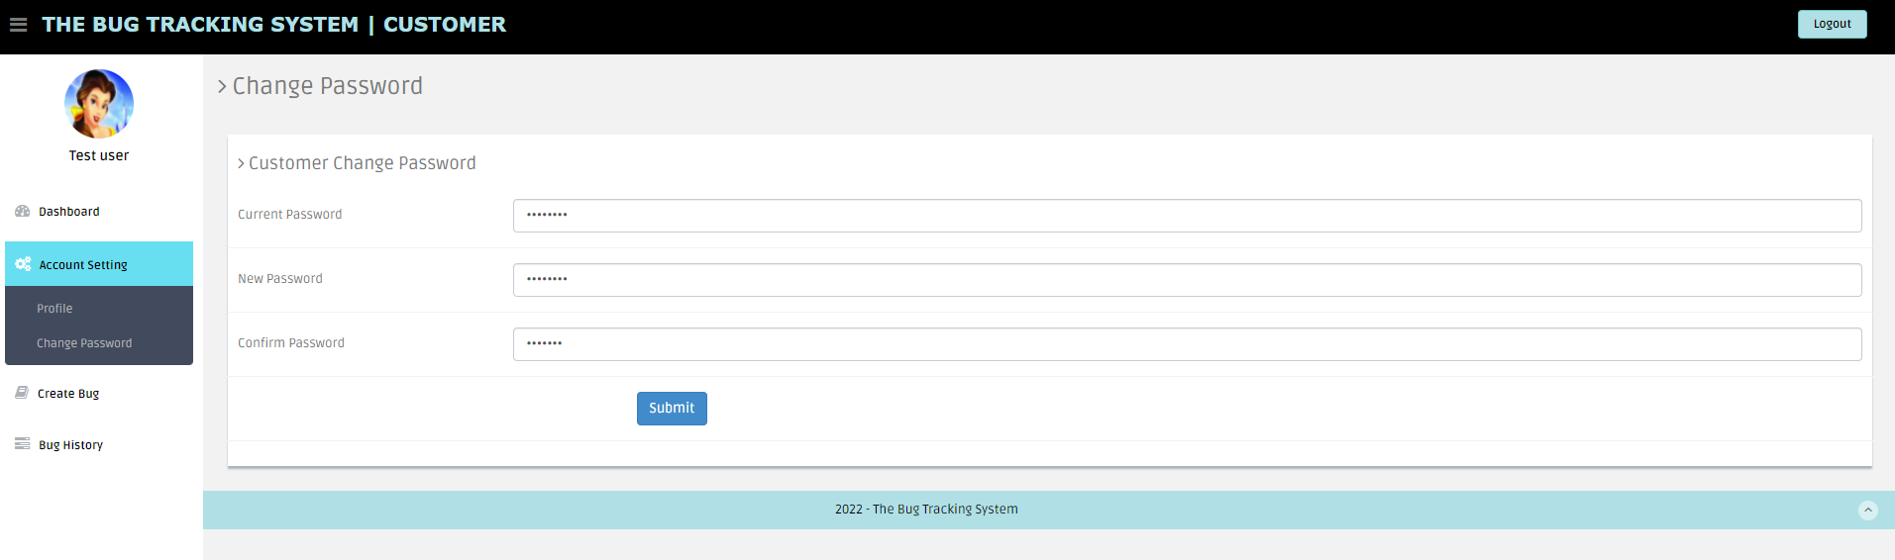

Figure 54: Customer Change Password Page

### Create Bug:

Customer uses button “Create Bug” to create new Bug/Ticket.

Web page will have below fields in Bug creation page:

1. Type: Type of ticket must be mentioned i.e., either Bug / New (Bug-existing issue, New-new requirement).
2. Summary: Title for the Bug.
3. Description: Describe Bug.
4. Status: It is “To Do” by default while creating.
5. Priority: Set bug priority can be set (low/medium /high).
6. Remarks: Comments can be added.
7. Attachments: Documents/Files related to bug can be uploaded.

Web page will populate below fields in the backend into the same record in the database:

1. Creation Date: Gets timestamp and populates this field.
2. Reporter: Current user will be the Bug reporter.
3. Last Updated Date: Timestamp of last updated changes.

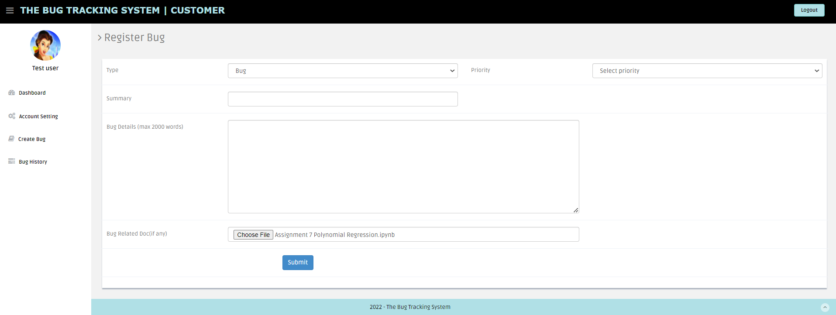

Figure 55: Bug Creation

### **Bug** History:

* Bug History Button displays all the bugs that were created by the customer.

Customer can view all the bugs that were created by current customer.

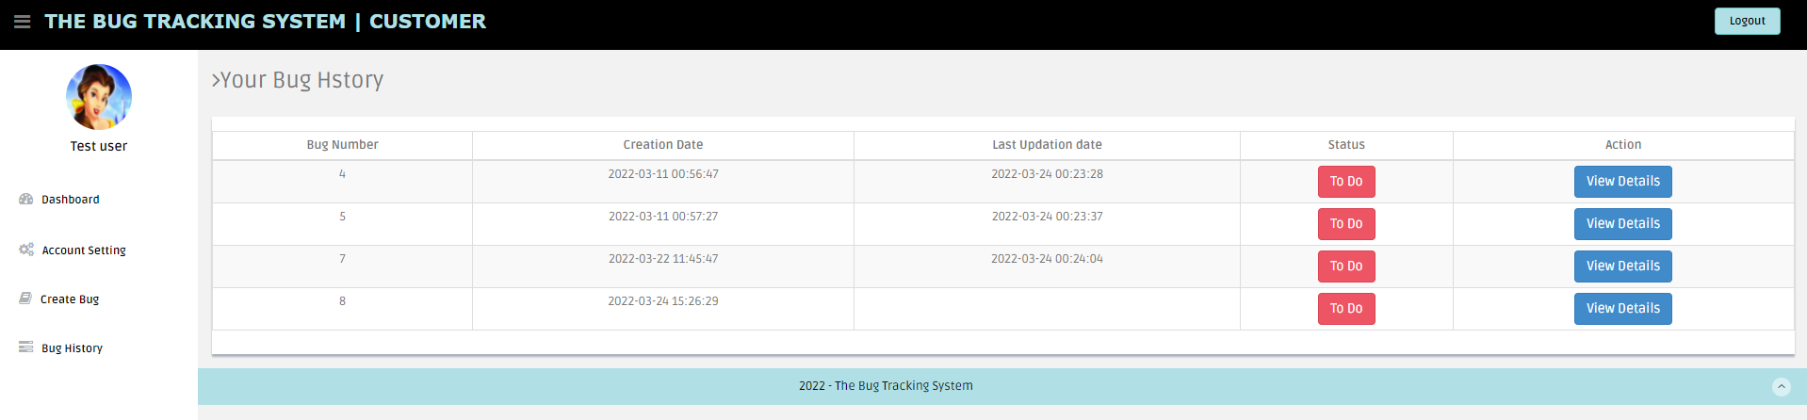

Figure 56: Customer Bug History Page

* By clicking on “View Details” button in the Action Column, customer can view bug details.

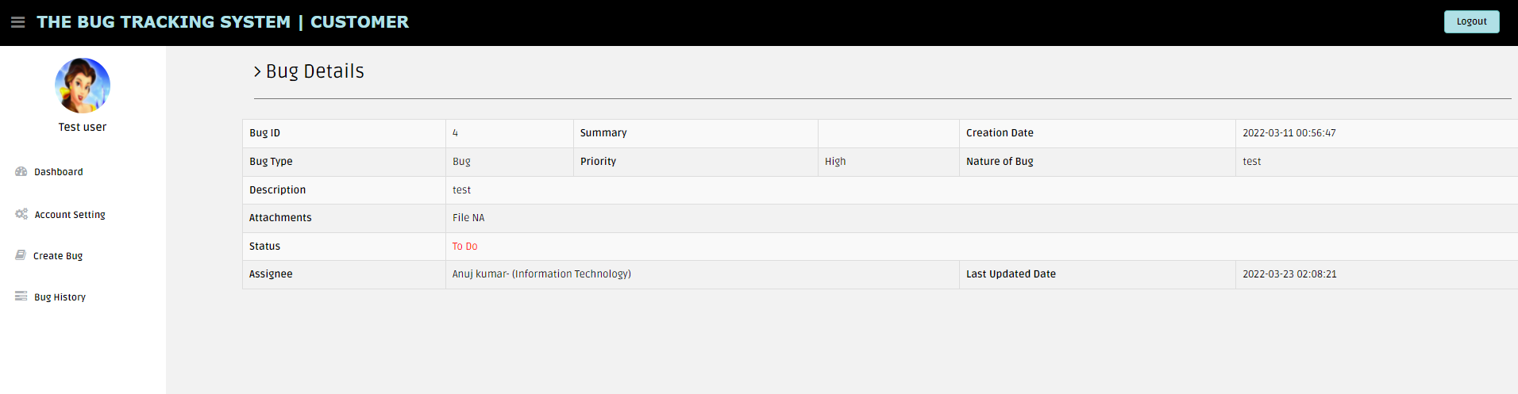

Figure 57: Customer Bug Details Page

## Manager View

Once the manager logs in, Dashboard is displayed by default.

### Account Setting:

Account settings can be accessed by clicking on the icon on the top-right corner. It has three main functions:

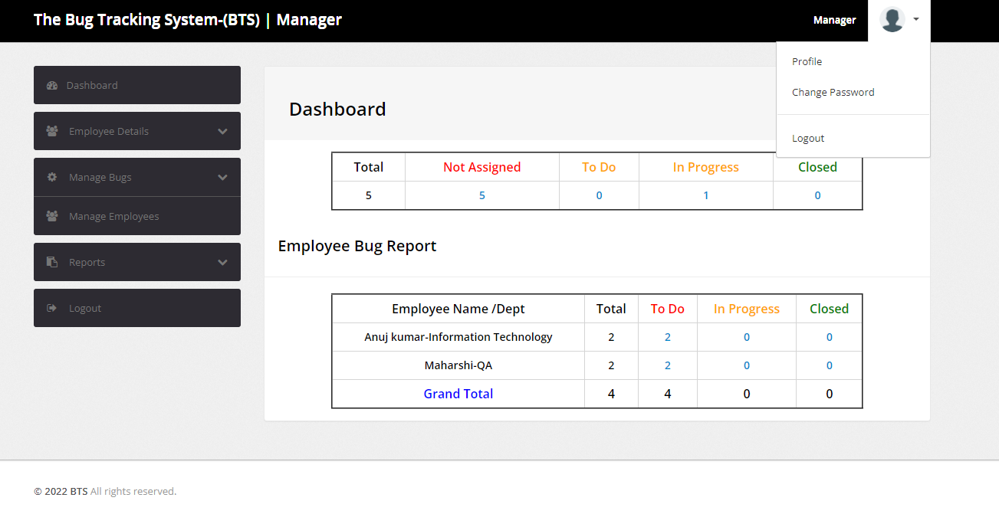

Figure 58: Manager Account Settings

#### Profile:

“Profile” button will display manager profile information and manager can also edit/update personal information.

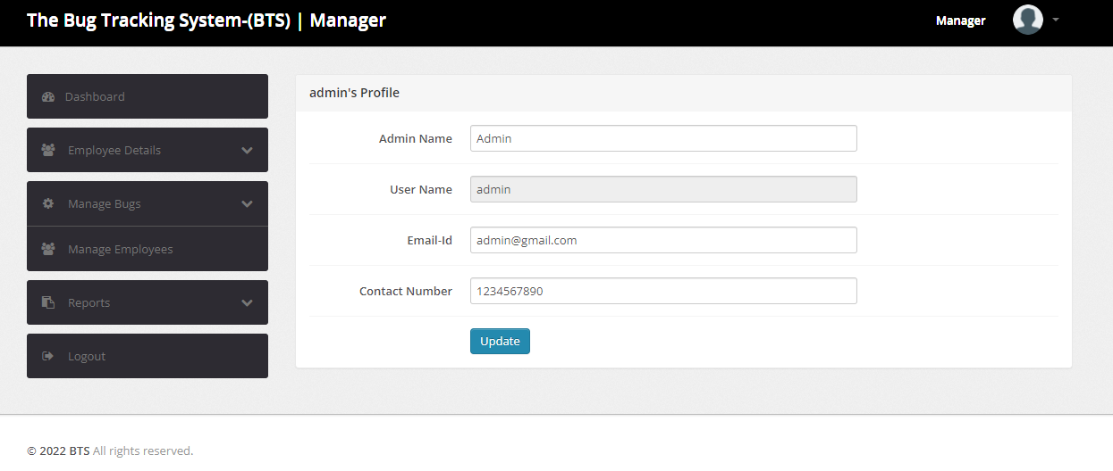

Figure 59: Manager Profile Information

#### Change Password:

“Change password” button is used for changing password. Customer can enter Current password, new password and Confirm password fields and submit for updating the password. If current password is wrong, “Oh Snap! Old password does not match” error is popped.

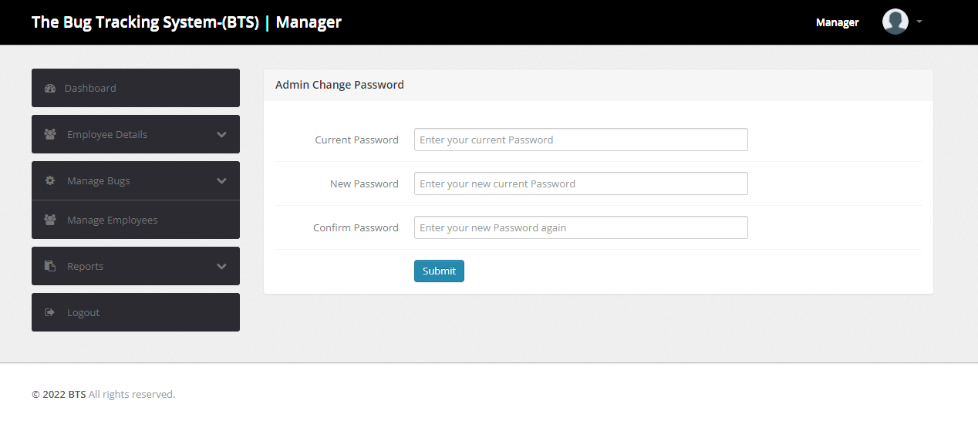

Figure 60: Manager Password Change Page

#### Logout:

User can logout just by clicking this button.

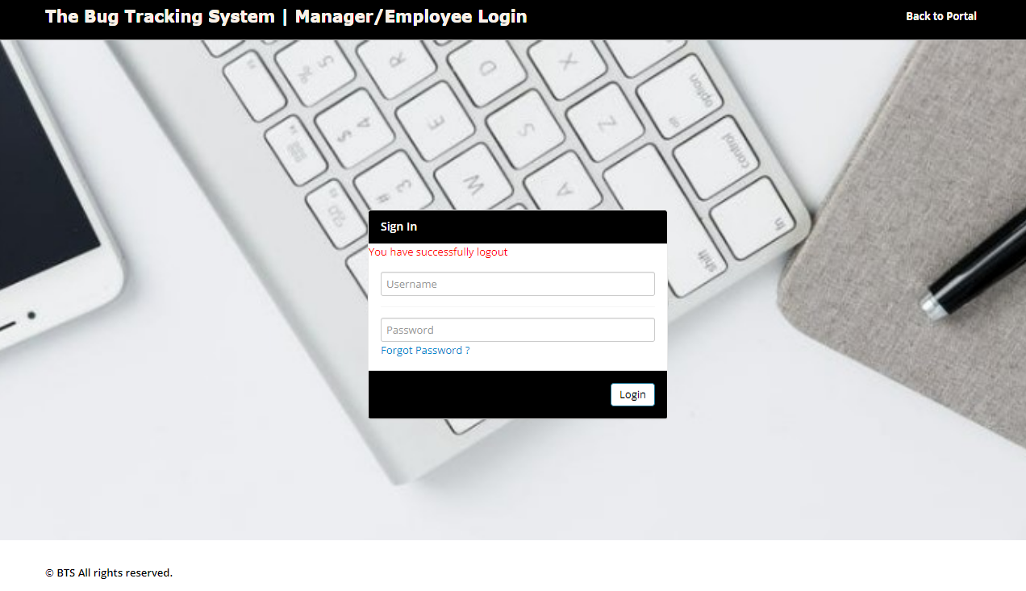

Figure 61: Manager successful Logout

### 3.2 Dashboard:

Dashboard interface displays all the tickets the employees and manager are currently working on.

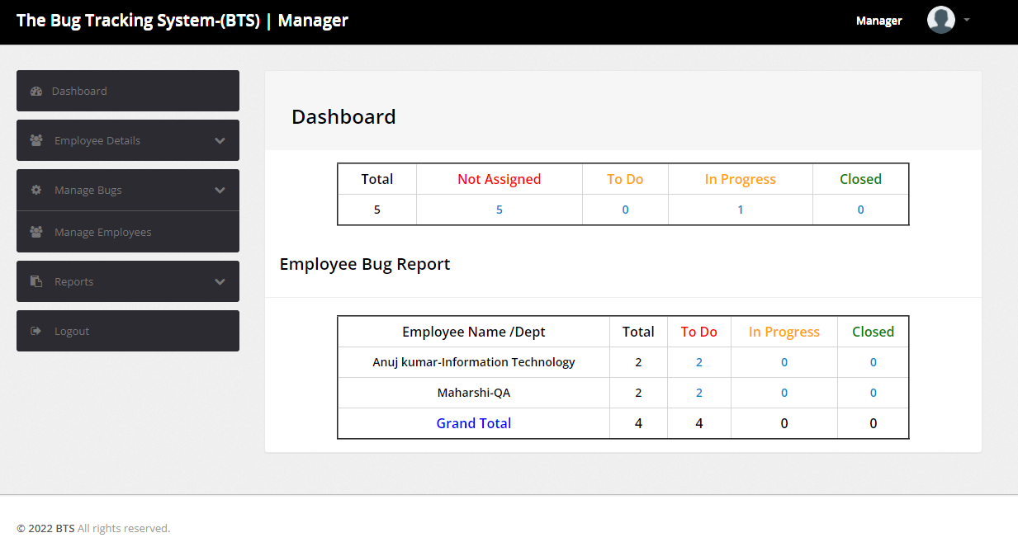

Figure 62: Manager Dashboard Display

### Employee Details:

Manager is the admin and can add new employees to the database from the “Employee Details” section. Also, employee details can be managed, edit button will update the details.

#### Add Employee:

New employee can be added from this section. Employee Name, Employee Department, Email ID, Contact Number, Username (for logging in) and Password (can be later changed by the employee) details should be entered and submitted to create a new employee.

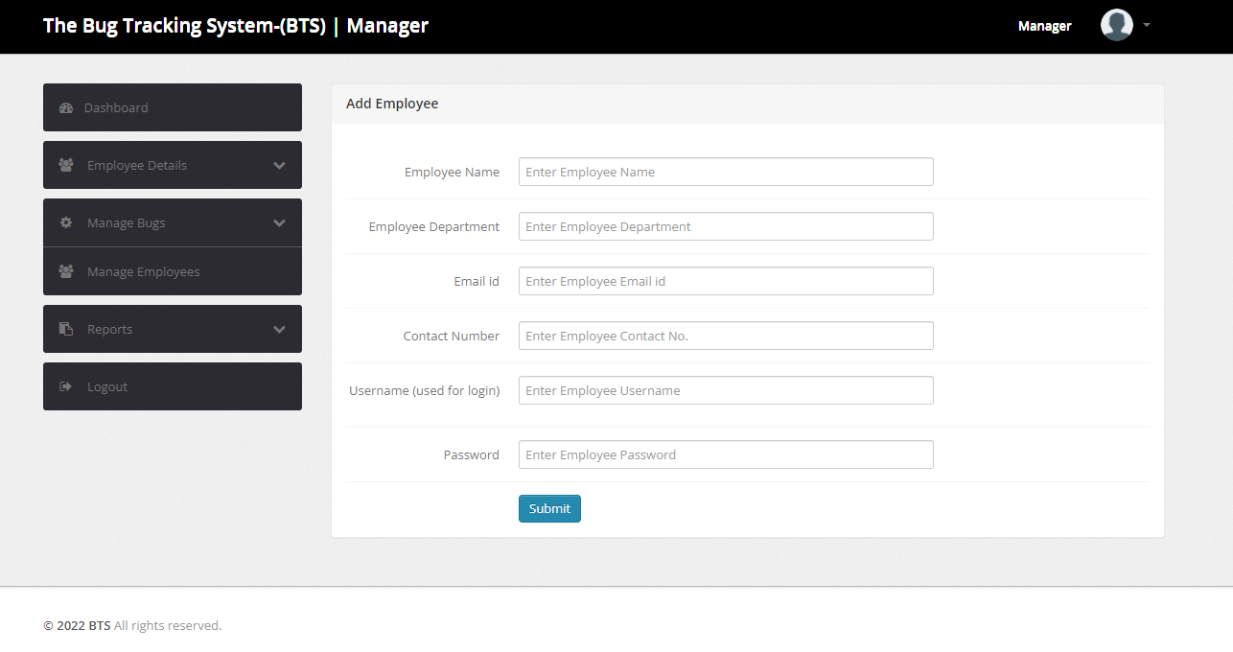

Figure 63: Manager Add Employee Page

#### Edit Employee:

It displays all employees under the manager**,** click on “Edit” button under action column against the employee to update details**.** Employee Name, Employee Department, Email ID, Contact Number and Employee Status (Active or Blocked) can be updated.

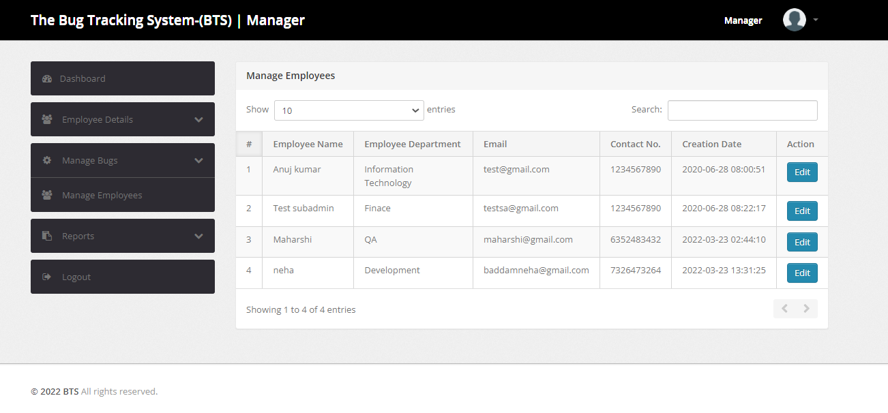

Figure 64: Manager view Edit Employee Page

By clicking on the “Edit” button in Action column against Employee Name, below page is displayed.

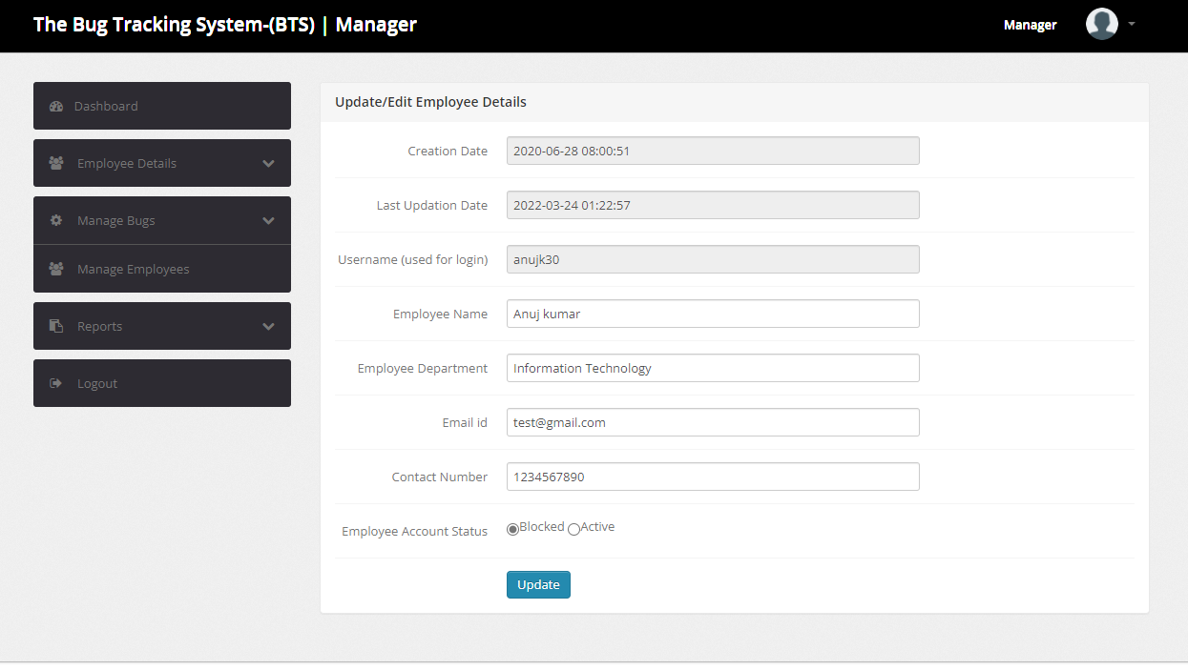

Figure 65: Manager View - Edit Employee Details Page

### Manage Bugs:

* This section shows all the To Do, Un-assigned, Closed and In Progress tickets.
* It displays Bug ID, Reporter, Creation Date, Status and Action Columns for the tickets.

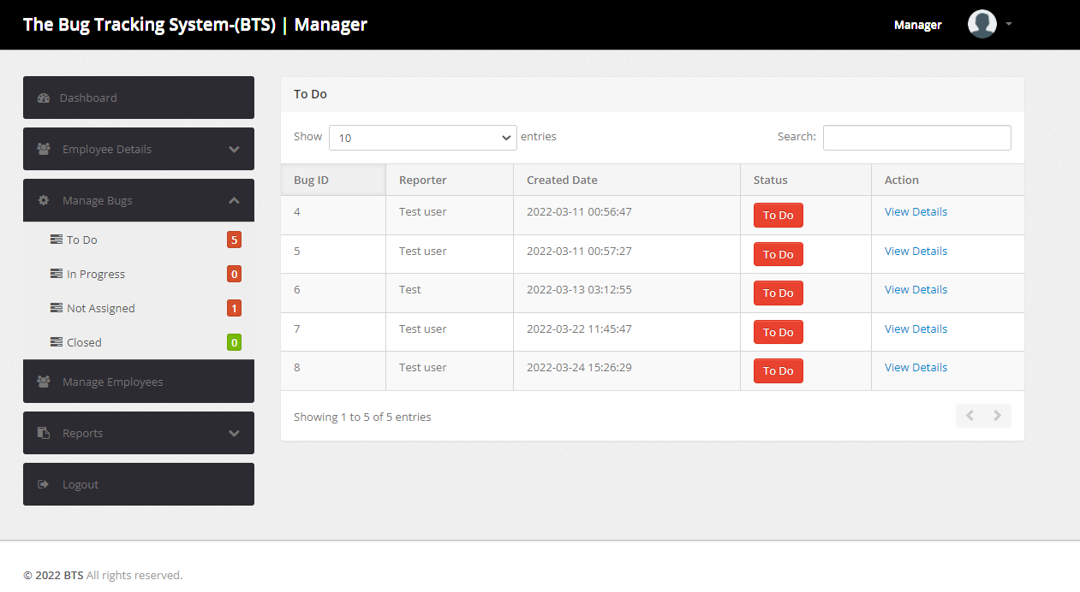

Figure 66: Manager Manage Bugs Page

* Manager can click on “View Details” button in Action column against the Bug to view Bug Details.

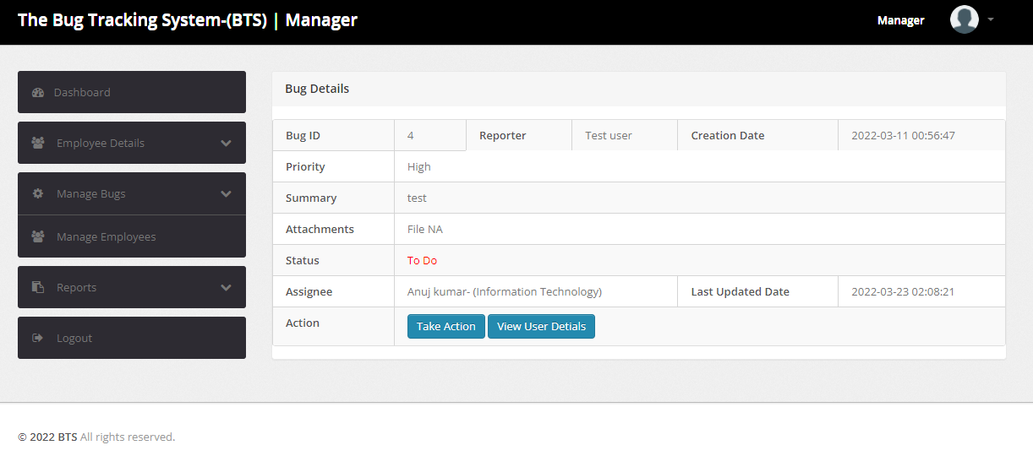

Figure 67: Manager Bug View Page

Action has two buttons “Take Action” and “View User Details”

* **Take Action:** This Button is used to update Bug status and add remarks. Click on “Submit” to update and “Close this window” to close the window.

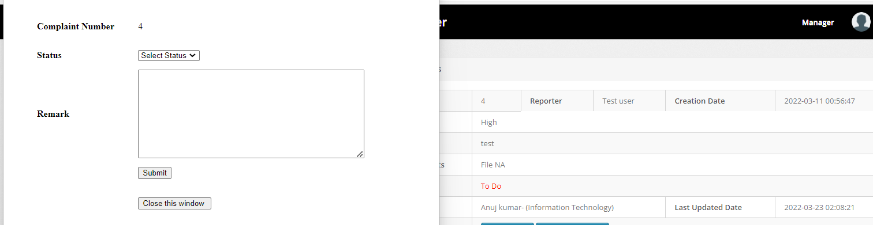

Figure 68: Bug View Take Action button

* **View User Details**: This Button is used to display all the information of the Reporter.

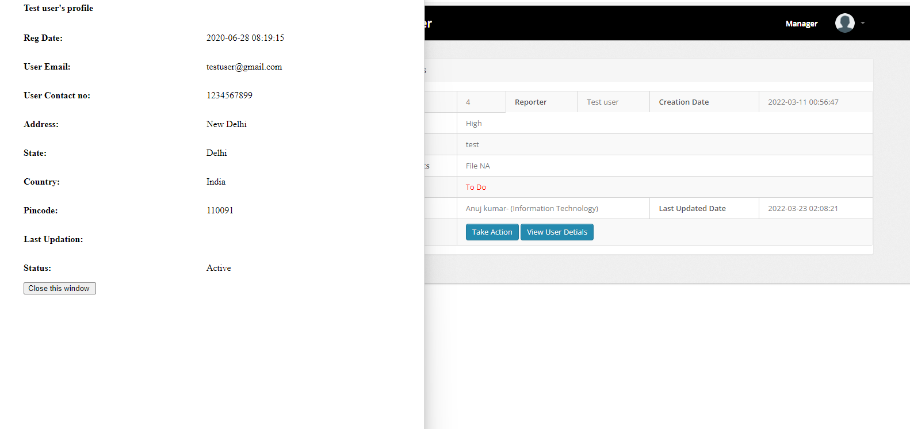

Figure 69: View User Details

### Manage Employees:

This section will help in managing employees i.e., either delete or view employee details. This shows Employee name, Email ID, Contact No., Creation Date and Action Column. Action Colum has two buttons as following:

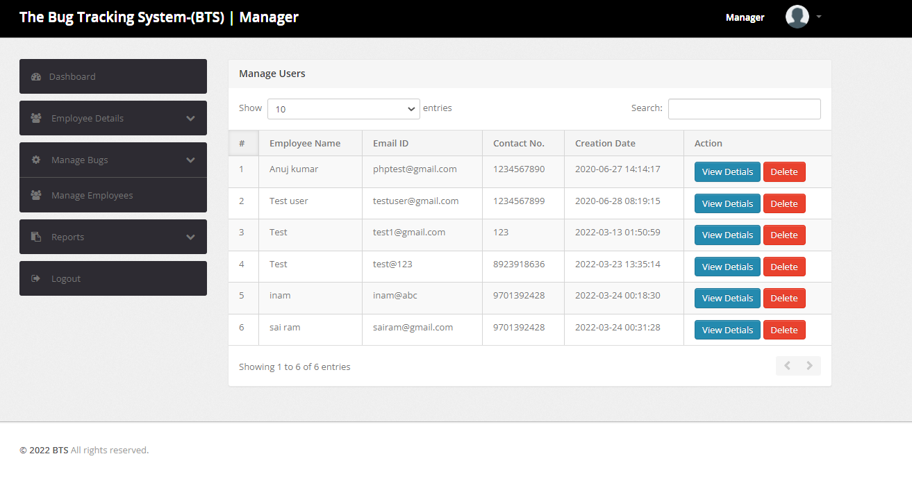

Figure 70: Manager Manage Employees Page

1. **View Details:** Displays Employee Details. Use button “Close this window” to close this window.

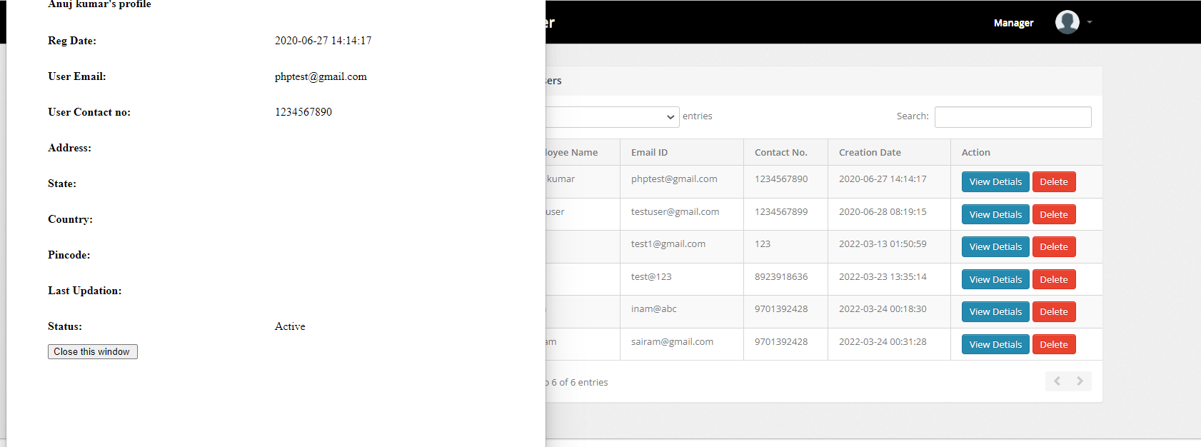

Figure 71: Manager View Employee Details

1. **Delete:** Delete will remove the user from the database.

### Reports:

There are two different reports that can be displayed.

#### Bug Report:

* Enter From and To Date from the calendar and click on “Submit” to display all Bugs Between the selected dates.

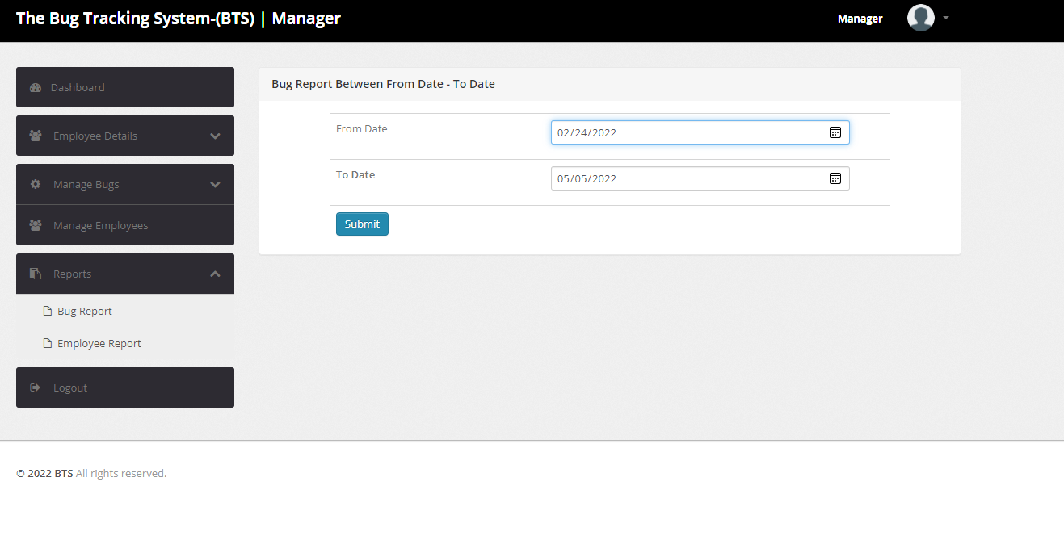

Figure 72: Bug Report Dates Insertion Page

Enter Bug Number in the “search” filter to search for the bug. “Show” filter determines how many rows to be displayed in the report

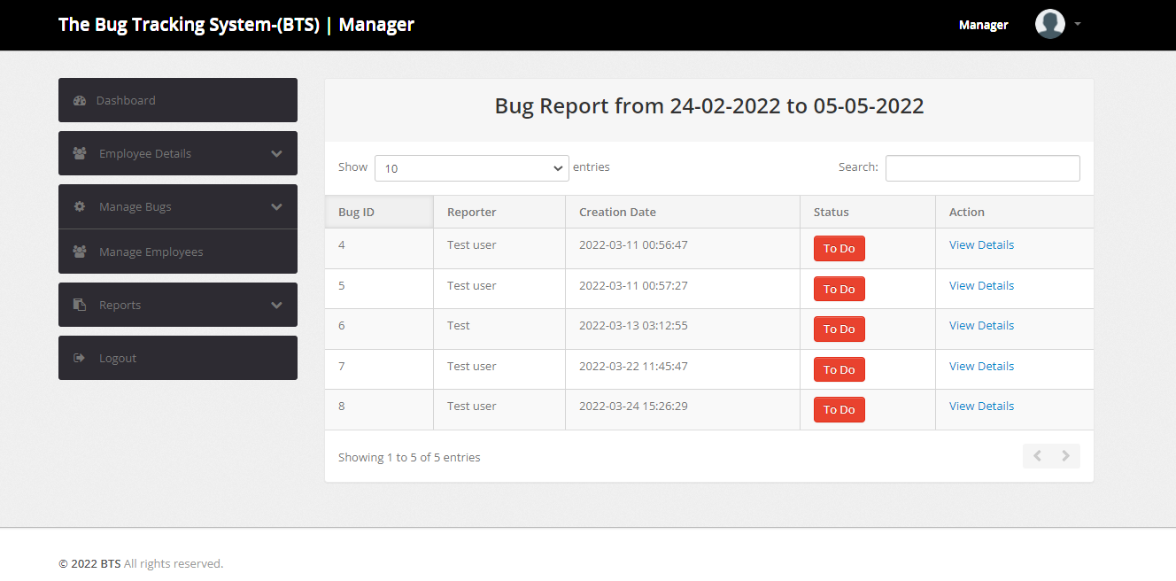

Figure 73: Bug Report

* It displays Bug ID, Reporter, Creation Date, Status and Action Columns of each Bug between the selected dates.

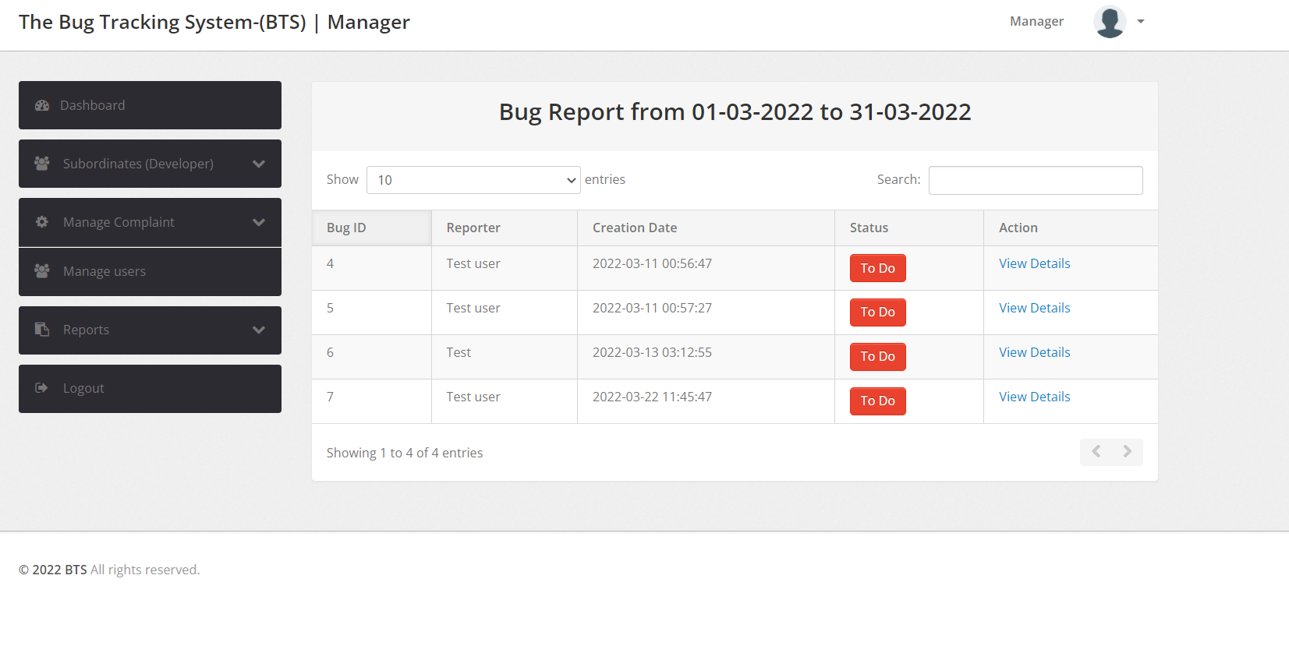

Figure 74: Bug Report between specified dates

* Action Column has **“View Details”** button, this redirects to the Bug View.

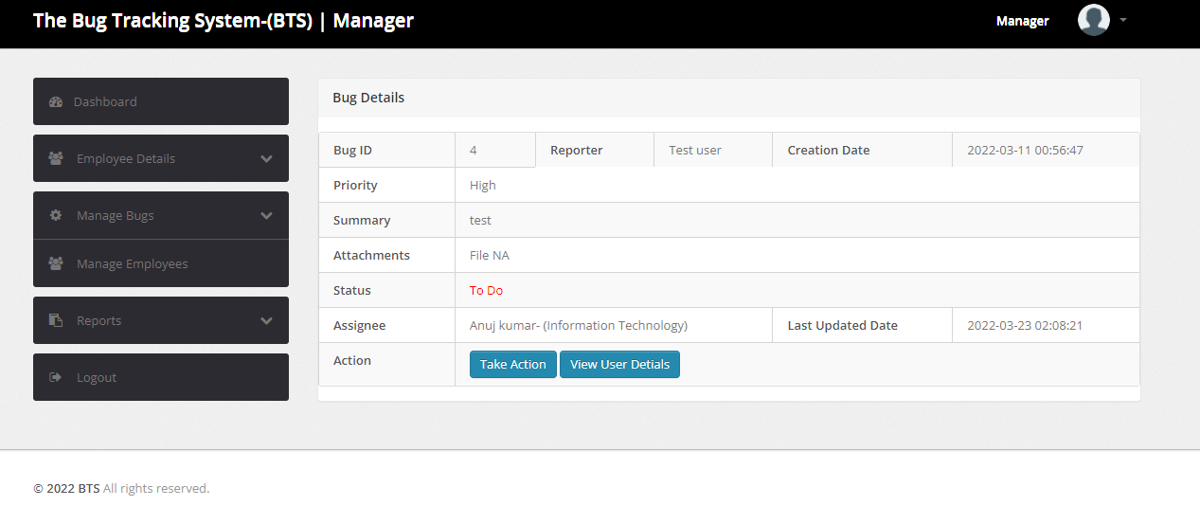

Figure 75: Bug View Page re-directed from Bug Report Page

#### Employee Report:

* Enter From and To Date from the calendar and click on “Submit” to displays all Employee Bug Details Between the selected dates.

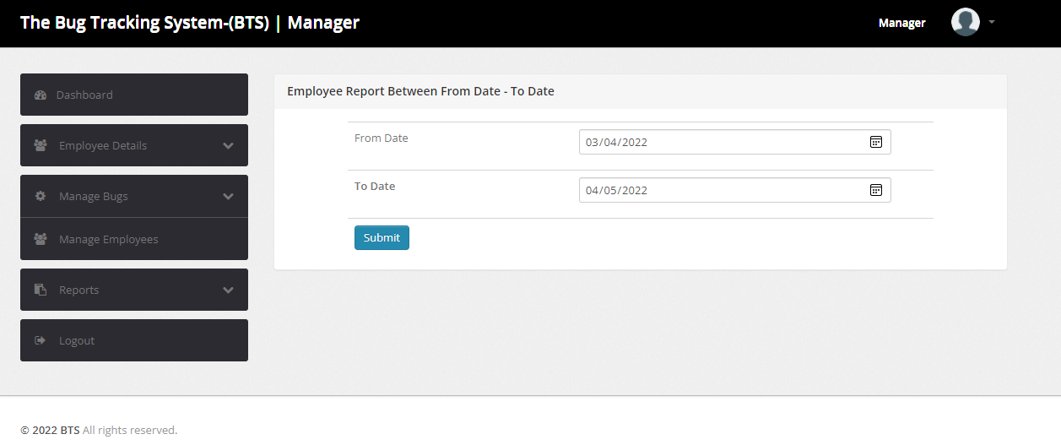

Figure 76: Employee Report

* It Displays Employee Name – Department, Total, To Do, In Progress and Closed Bugs with respect to each employee under the manager.

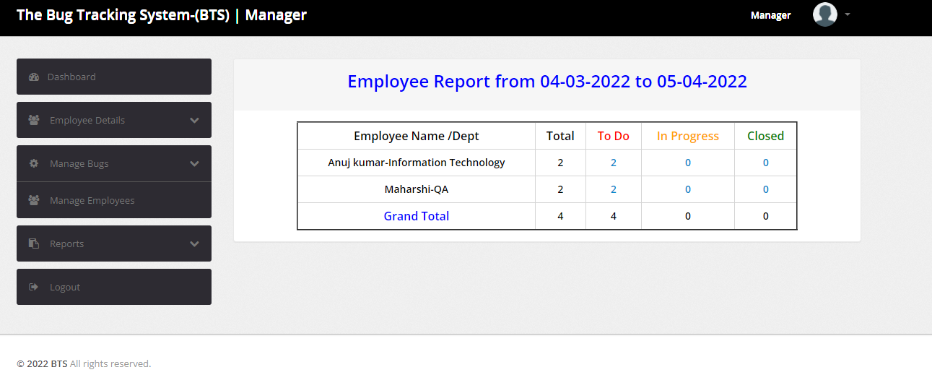

Figure 77: Employee Report between specified dates

### Logout:

This button will log the user out.



Figure 78: Manger logout

## Employee View

Once the employee logs in, Dashboard is displayed by default.

### Account Setting:

Account settings can be accessed by clicking on the icon on the top-right corner. It has three main functions:

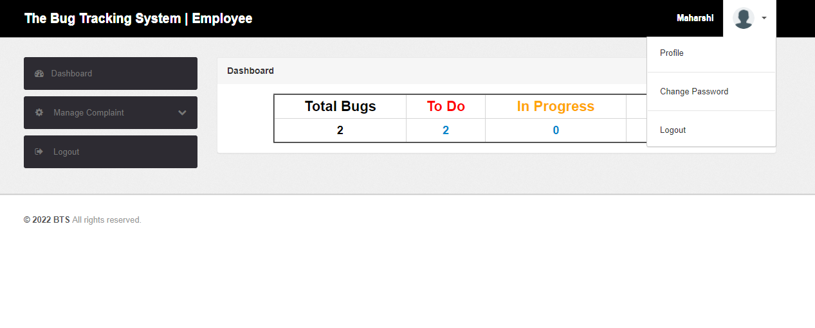

Figure 79: Employee Account settings

#### Profile:

“Profile” button will display manager profile information and edit/update personal information.

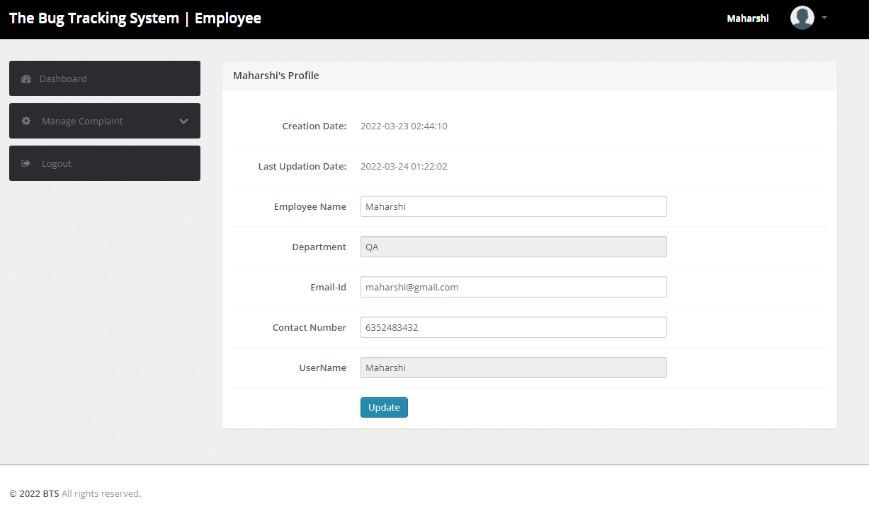

Figure 80: Employee Profile Information

#### Change Password:

“Change password” button is used for changing password. Enter Current password, new password and Confirm password fields and submit for updating the password. If current password is wrong, “Oh Snap! Old password does not match” error is popped.

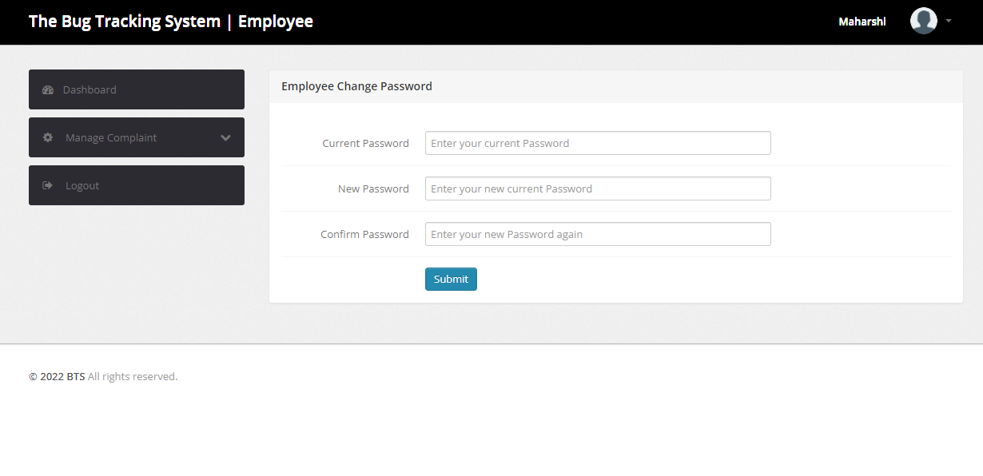

Figure 81: Employee Change Password Page

#### Logout:

User can logout just by clicking this button.



Figure 82: Employee Logout Page

### Dashboard:

Dashboard displays count of all the tickets the employee is currently working on.

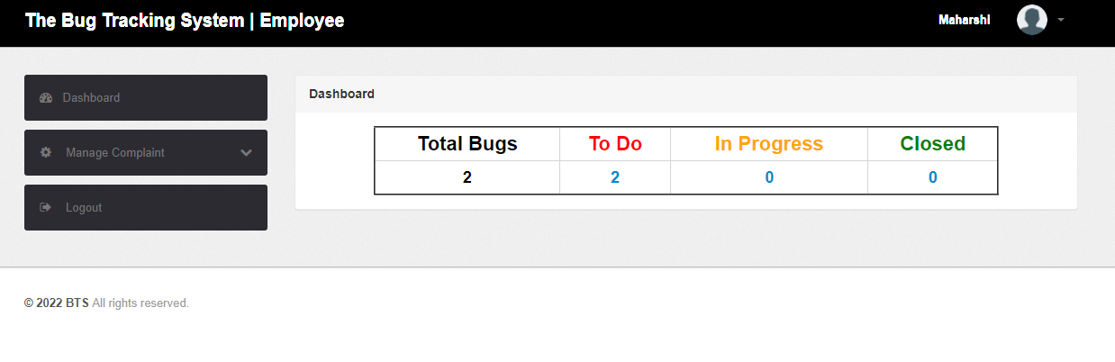

### Manage Bugs:

* This section shows all the To Do, Un-assigned, Closed and In Progress tickets.

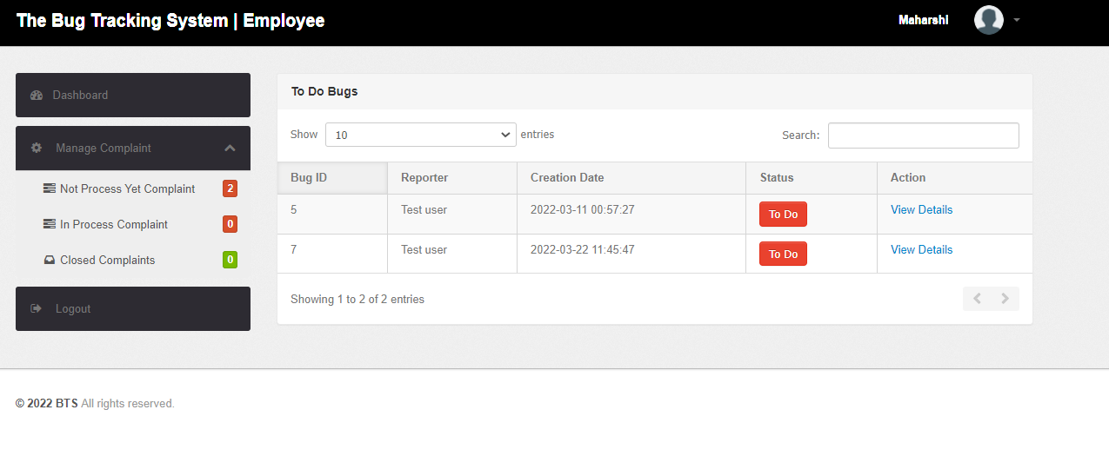

Figure 83: Employee Mange Bugs

* It displays Bug ID, Reporter, Creation Date, Status and Action Columns for the tickets.
* Click on “View Details” button in Action column against the Bug to view Bug Details. This will redirect to the Bug View.
* is assigned.

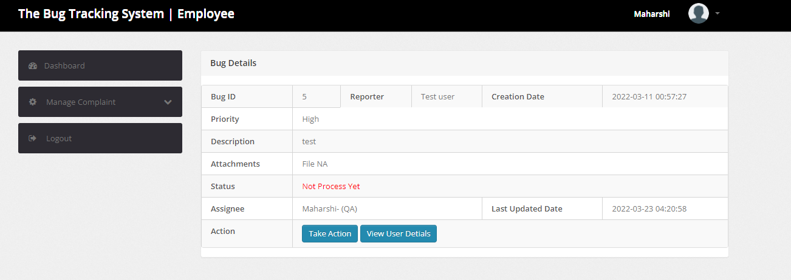

Figure 84: Employee Bug View

Action has two buttons “Take Action” and “View User Details”

* **Take Action:** This Button is used to update Bug status and add remarks. Click on “Submit” to update and “Close this window” to close the window.

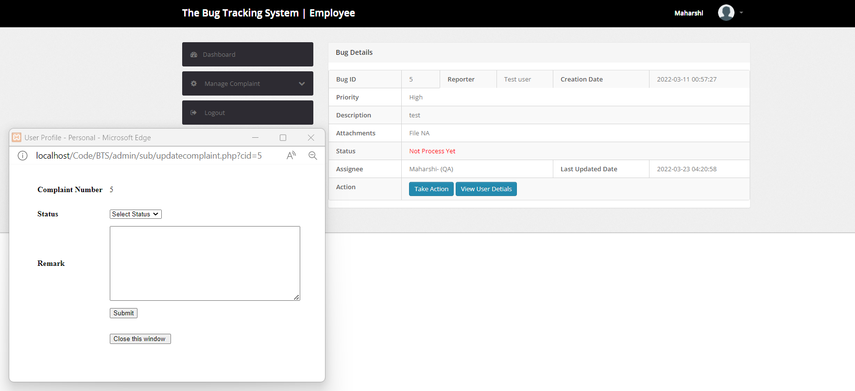

Figure 85: Employee Bug View Take Action button

* **View User Details**: This Button is used to display all the information of the Reporter.

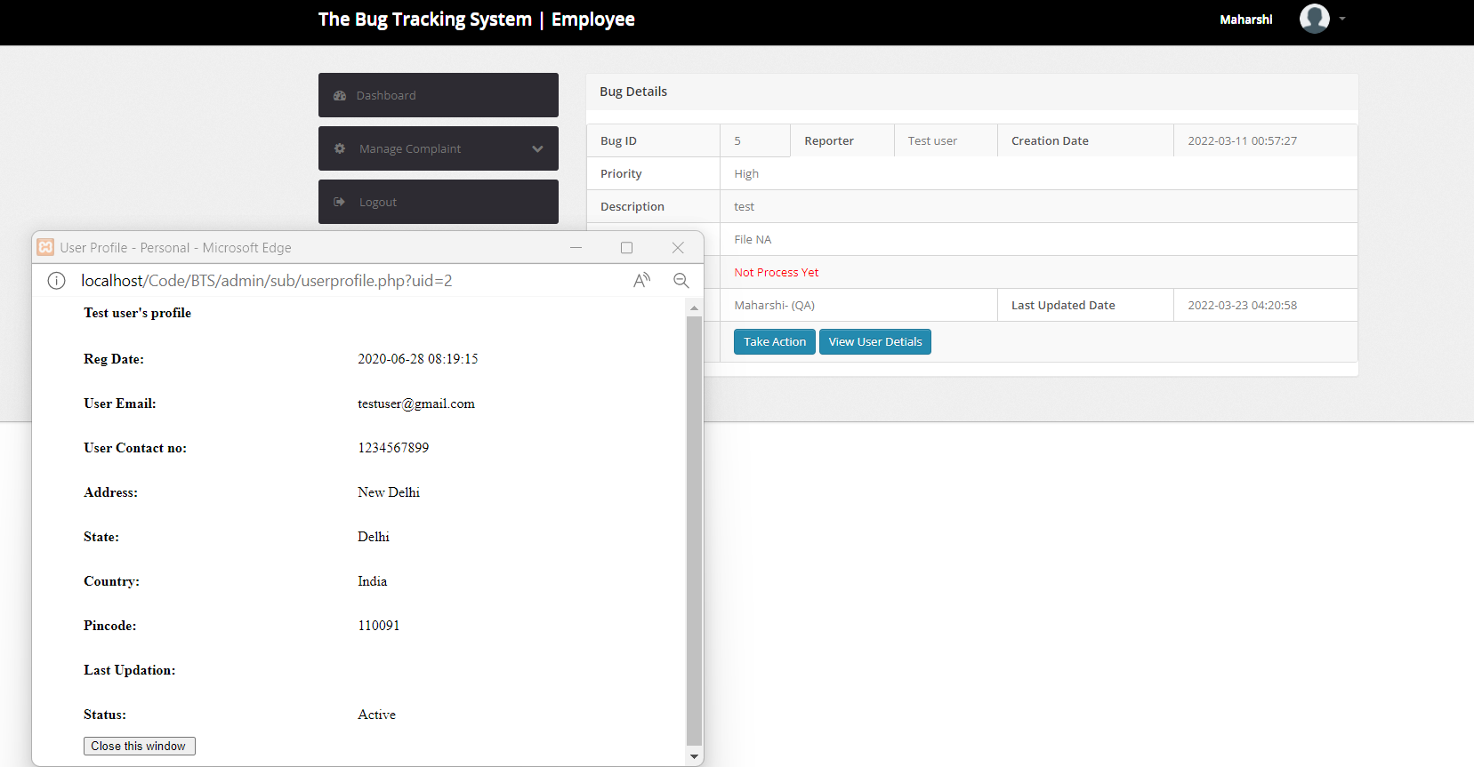

Figure 86: Employee Bug View "View User Details" Page

### Logout:

This button will log the user out.



Figure 87: Employee successful Logout

# Program Compilation and Run Instructions

## Program Instructions

As this is a PHP coded project, it does not need any compilation. Below are the run instructions:

* 1. Install Xampp on your system - <https://www.apachefriends.org/download.html>
  2. Open GitHub (<https://github.com/nehabaddam/Software-Engineering-Project.git>) and download file “[Software-Engineering-Project](https://github.com/nehabaddam/Software-Engineering-Project)/[Code](https://github.com/nehabaddam/Software-Engineering-Project/tree/main/Code)/**Phase-1**/BTS.zip” .Extract “BTS.zip” folder to C:\xampp\htdocs folder on the laptop/PC.

Note: Make sure that the “BTS” folder is extracted and placed correctly in path C:\xampp\htdocs

* 1. Open the Xampp control panel and start the Apache and MySQL Modules.

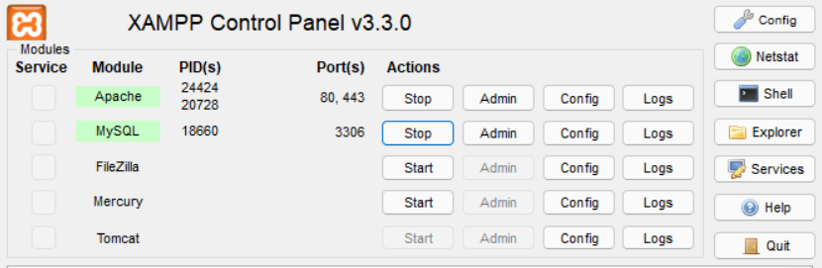

Figure 88: Xampp Control panel

* 1. Open PHPMyAdmin (<http://localhost/phpmyadmin>), Create a database with name bts and import the “bts.sql” file from the GitHub “Code/Phase-1” folder.

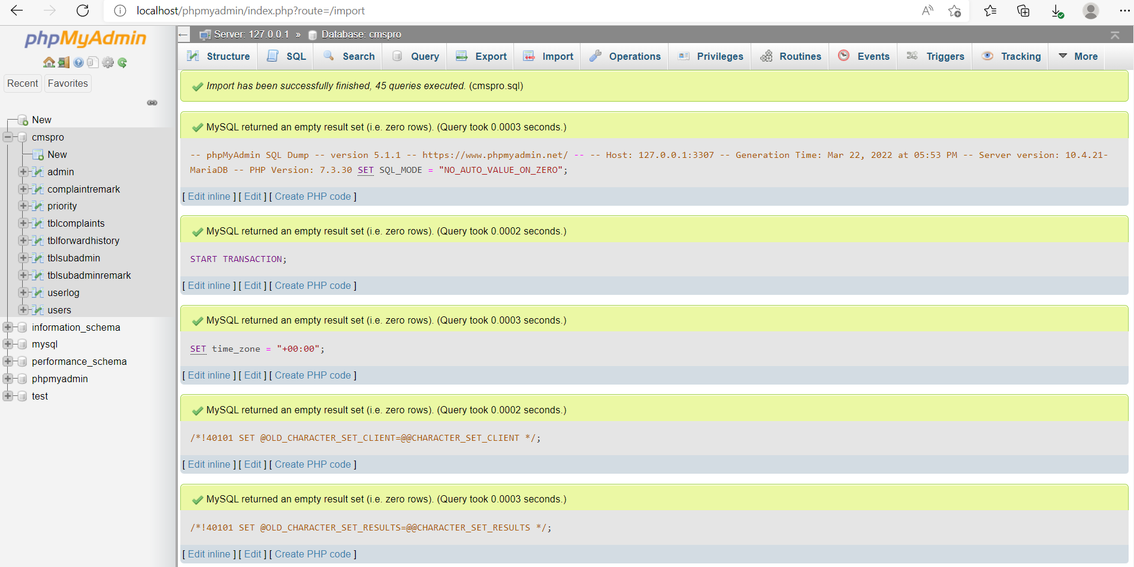

Figure 89: PhpMyAdmin

* 1. Type the URL <http://localhost/BTS>

## Testing Instructions

As it is web application, most of the test cases executed as a part of Phase-1 were directly evaluated on the browser. Below are the steps:

1. Firstly, Setup the Program by executing all the steps provided in the Program Instructions section.

2. Now, execute each test case provided in the test cases section of this document.

# Feedback

Feedback received:

1. We have been asked to change the user interface in all modules to make it more colorful and interactive.
2. We have been asked to add comments in the code for easy understanding of the functionality.

Actions taken based on the feedback:

1. We have changed the User Interface.
2. We have added comments to the code.

# Accomplishments

A brief reflection on what has been accomplished, what went well and could be improved:

1. We have added few more functionalities in Phase-2, for example changing customer profile pictures and storing it in database. This part was difficult as we had no experience in adding such features before.
2. Changed the existing application layer for the webpage. We have used JAVASCRIPT for Application layer development. That helped in faster loading of webpages. But the UI in Phase-1 was not up to the mark, so we have changed many features for easy usage of the application.
3. Developed Webpages for extended functionalities in all Modules. As most of the team members were not aware of jQuery and Ajax, we have been having many meetings for knowledge transfer.
4. Integrated Database with the Front-End applications for the extended functionalities, frequent training and meetings helped in completing the Phase-2 version on time.
5. Developed back-end code for extended functionalities for Customer, Manager and Employee Modules.
6. Integrated Components in the Customer, Manager and Employee Modules with the existing Front-End Applications and the Database. Because we have started integrating in phase-1, we could easily finish integration process in Phase-2.
7. Performed testing on the overall code. The application is deployed through XAMPP server, many test cases were prepared and tested as a part of integrated testing.

# Member contribution table

|  |  |  |  |
| --- | --- | --- | --- |
| **Member Name** | **Contribution Description** | **Overall Contribution (%)** | **Note (If Applicable)** |
| **Neha Goud Baddam** | Functional and Non-Functional requirement specification and Full Stack Development, worked on all components. | 13 |  |
| **Vamsi Sai Konidena** | Program Compilation and Run Instructions. Front-end development of Customer modules. | 13 |  |
| **Reshmi Chowdary Divi** | Test Cases and Back-end development of extended functionalities of employee and manager modules. | 13 |  |
| **Prem Kumar Maddula** | Feedback and accomplishments. Back-end development of manager modules. | 13 |  |
| **Rahul Mandaloju** | Front-end and UI development of extended functionalities of customer, employee, and manager modules. | 13 |  |
| **Harika Uppalapati** | User Manual. | 10 |  |
| **Purandhara Maharshi Chidurala** | GitHub updating. Application and UI Development for Phase-2 Customer module. | 12 |  |
| **Shiva Surya Vardhan Reddy** | UML Designs and Integrated Testing. | 13 |  |